IUPAC Task Group on Atmospheric Chemical Kinetic Data Evaluation – Data Sheet ROO_5
Datasheets can be downloaded for personal use only and must not be retransmitted or disseminated either electronically or in hardcopy without explicit written permission. The citation for this data sheet is: IUPAC Task Group on Atmospheric Chemical Kinetic Data Evaluation, (http://iupac.pole-ether.fr).
This datasheet last evaluated: June 2018; last change in preferred values: June 2018.

i-C₃H₇O₂ + NO → i-C₃H₇O + NO₂ (1)
i-C₃H₇O₂ + NO + M → i-C₃H₇ONO₂ + M (2)

ΔH°(1) = -40.5 kJ·mol⁻¹
ΔH°(2) = -212.2 kJ·mol⁻¹

Rate coefficient data (k = k₁ + k₂)

k/cm³ molecule⁻¹ s⁻¹ | Temp./K | Reference | Technique/ Comments
Absolute Rate Coefficients
(3.5 ± 0.3) × 10⁻¹² | 298 | Adachi and Basco, 1982 | FP-AS
(5.0 ± 1.2) × 10⁻¹² | 290 | Peeters et al., 1992 | DF-MS (a)
2.7 × 10⁻¹² exp[(360 ± 60)/T] | 201-401 | Eberhard et al., 1996 | F-CIMS (b)
(9.0 ± 1.5) × 10⁻¹² | 298
(9.1 ± 1.5) × 10⁻¹² | 298 | Eberhard and Howard, 1996 | F-CIMS (c)
4.3 × 10⁻¹² exp[(268 ± 56)/T] | 213-298 | Chow et al., 2003 | F-CIMS (d)
(1.05 ± 0.14) × 10⁻¹¹ | 298
(8.0 ± 1.5) × 10⁻¹² | 298 | Xing et al., 2005 | LP-MS (e)
Branching Ratios
k₂/k = 0.042 ± 0.003 (1 bar air) | 299 | Atkinson et al., 1982;  Carter and Atkinson, 1989 | (f)
k₂/k = 1.815 × 10⁻⁴ exp(1020/T)  (133 mbar N₂) | 213-298 | Chow et al., 2003 | F-CIMS (d)
k₂/k = 0.005 (133 mbar N₂) | 298
k₂/k₁ = (6.0 ± 1.1) × 10⁻³ (55 Torr N₂) | 298 | Butkovskaya et al., 2010 | F-CIMS (g)
k₂/k₁ = (27.4 ± 6.6) × 10⁻³ (500 Torr N₂)

Comments

(a) Low pressure flow tube at 2.7 mbar He. Rate constant derived from analysis of NO₂ growth profiles.
(b) i-C₃H₇O₂ radicals produced by reaction of O₂ with i-C₃H₇ radicals produced by thermal decomposition of isobutyl nitrate. i-C₃H₇O₂ was detected as its parent negative ion formed by reaction with O₂⁻. k determined by pseudo-first order loss of i-C₃H₇O₂ in the presence of NO.
- i-C₃H₇O₂ produced by reaction of O₂ with i-C₃H₇ produced in a low frequency RF discharge through i-propyl iodide.
- Turbulent flow reactor at 100 Torr (133 mbar) N₂ total pressure. C₃H₇O₂ radicals were generated by the reaction of Cl atoms with C₃H₈ in the presence of O₂, thus both n-C₃H₇O₂ and i-C₃H₇O₂ were present and the rate coefficients measured are overall values for both isomers, which were detected as C₃H₇OOH⁺(H₂O)₃ following reaction with H⁺(H₂O)₄ ions. For branching ratio measurements, i-C₃H₇O₂ was selectively generated from the reaction of H atoms with C₃H₆ in the presence of O₂. i-C₃H₇ONO₂ was detected using H⁺(H₂O)₄ ions; NO₂ was detected as NO₂- following electron transfer from SF₆⁻.
- i-C₃H₇O₂ generated by reaction of i-C₃H₇ with O₂, whereby i-C₃H₇ radicals were generated in the 193 nm photolysis of i-C₃H₇Br, or the 248 nm photolysis of i-C₃H₇I. i-C₃H₇O₂ was detected as the negative parent ion. The bath gas was was 4 – 5.3 mbar (He). Owing to poor sensitivity, and resultant side/secondary reactions the rate coefficient was extracted by numerical modelling of a complex reaction scheme.
- Photolysis of CH₃ONO-NO-C₃H₈-air or Cl₂-NO-C₃H₈-air mixtures at a total pressure of 1 bar. The branching ratio was determined from the measured yields of i-C₃H₇ONO₂ and the consumption of C₃H₈. Carter and Atkinson (1989) have re-evaluated the branching ratio, cited above, from the original data (Atkinson et al., 1982) on the basis of revised data for the rate coefficients of the HO radical reactions with alkanes.
- Turbulent flow reactor with CIMS detection of products using F⁻ primary ions. Branching ratios (k₂ / k₁) were derived by monitoring the formation of C₂H₅ONO₂ (detected as NO₃⁻) relative to CH₃C(O)CH₃, the latter formed (at a yield of 0.16 ± 0.025) in the reaction of i-C₃H₇O₂ (from reaction 1) with NO.

Preferred Values

Parameter | Value | T/K
k /cm³ molecule⁻¹ s⁻¹ | 9.0 × 10⁻¹² | 298
k /cm³ molecule⁻¹ s⁻¹ | 2.7 × 10⁻¹² exp(360/T) | 200-410
α | 1.95 × 10⁻²²
β | 0.947
$$Y_{0}^{300}$$ | 0.435
$$m_{0}$$ | 2.99
$$m_{∞}$$ | 4.69
F | 0.556
k₂/k (1 bar) | 0.035 | 298
Reliability
Δ log k | ± 0.1 | 298
Δ E/R | ± 100 | 200-410
Δ log (k₂/k) | ± 0.3 | 213-320

Comments on Preferred Values
The data from Eberhard et al. (1986) give a rate coefficient at 298 K which is significantly larger that the values obtained by Adachi and Basco (1982) or Peeters et al. (1992) and is close to the value obtained for a range of alkyl peroxy radicals at 298 K. In addition, the data of Chow et al. (2003), who measured a weighted average value for n-C₃H₇O₂ and i-C₃H₇O₂ are in good agreement, which confirms that n-C₃H₇O₂ and i-C₃H₇O₂ have similar rate coefficients for reaction with NO. The rather indirect measurement of Xing et al. (2005) is also in broad agreement. The preferred value for k₂₉₈ and the temperature dependence is that reported by Eberhard et al. (1996).

The three studies of the branching ratio to i-C₃H₇ONO₂ formation indicate that k₂/k increases with increasing pressure, with a value of circa 0.04 at one bar pressure and 298 K. Although the data of Chow et al. (2003) are not precise enough to accurately define the trend, the formation of i-C₃H₇ONO₂ is also favoured by low temperatures (Chow et al., 2003) as expected. The datasets of Carter and Atkinson (1989), Chow et al. (2003) and Butkovykaya et al (2010) are reasonably consistent with the temperature dependent fall-off parameterisation of Carter et al (1985) (see below) when multiplied by a factor 1.5. Note that later parametzerisations from the same group used a much weaker temperarure dependence and do not reproduce the increase in branching ratio at low temperatures (at 100 Torr total pressure) obseved by Chow et al. (2003).

$$\frac{k_{2}}{k}= 1.5\left[\frac{Y_{0}^{300}[M]{(T/300)}^{-m_{0}}}{1+\frac{Y_{0}^{300}[M]{(T/300)}^{-m_{0}}}{Y_{∞}^{300}{(T/300)}^{-m_{∞}}}}\right]F^{Z}$$

Where $Z= {\left\{1+{\left[log\left\{\frac{Y_{0}^{300}[M]{(T/300)}^{-m_{0}}}{Y_{∞}^{300}{(T/300)}^{-m_{∞}}}\right\}\right]}^{2}\right\}}^{-1}$ and

$$Y_{0}^{300}= αe^{βn}$$

The uncertainty in the branching ratio has been increased to reflect the data quality in the only study of the temperature dependence.

References

Adachi, H. and Basco, N.: Int. J. Chem. Kinet. 14, 1243, 1982.
Arey, J., Aschmann, S. M., Kwok. E. S. C. and Atkinson, R.: J. Phys. Chem. A 105, 1020, 2001.
Atkinson, R., Aschmann, S. M., Carter, W. P. L., Winer, A. M. and Pitts, Jr. J. N.: J. Phys. Chem. 86, 4563, 1982.
Carter, W. P. L. and Atkinson, R.: J. Atmos. Chem. 3, 377-405, 1985.
Carter, W. P. L. and Atkinson, R.: J. Atmos. Chem. 8, 165-173, 1989.
Chow, J. M., Miller, A. M and Elrod, M. J.: J. Phys. Chem. A 107, 3040, 2003.
Eberhard, J., Villalta, P. W. and Howard, C. J.: J. Phys. Chem. 100, 993, 1996.
Eberhard, J. and Howard, C. J.: Int. J. Chem. Kinet. 28, 731, 1996.
Peeters, J., Vertommen, J. and Langhans, I.: Ber. Bunsenges. Phys. Chem. 96, 431, 1992.
Xing, J.-H. and Miyoshi, A.: J. Phys. Chem. A 109, 4095, 2005.

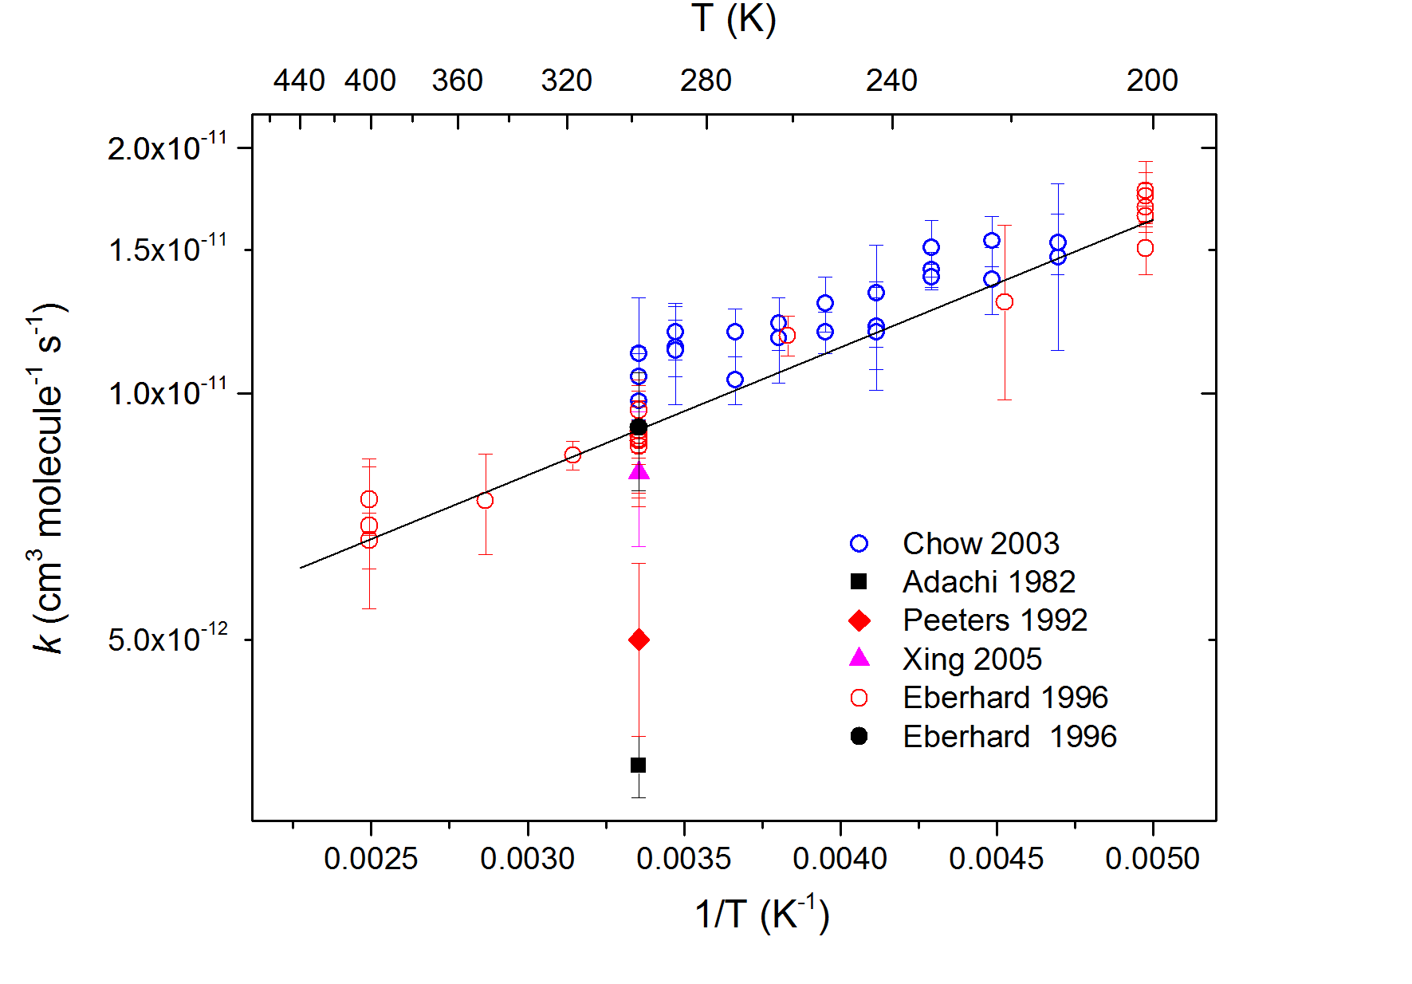

Rate constants for i-C₃H₇O₂ + NO. The solid line represents the prefered values. The data of Chow et al are for a mixture of i-C₃H₇O₂ and n-C₃H₇O₂.

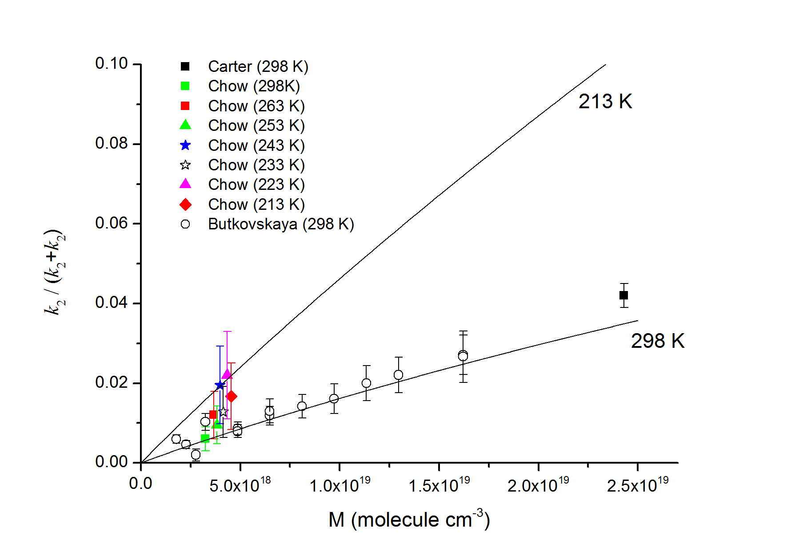

Branching ratio, k₂ / (k₁+k₂), for formation of C₃H₇ONO₂ in the reaction between i-C₃H₇O₂ and NO. The solid lines are derived from the parameterisation given by Carter and Atkinson et al. (1985) multipled by a factor of 1.5.

