### IUPAC Task Group on Atmospheric chemical Kinetic Data Evaluation – Data Sheet VI.A4.2 HET_SL_2

Datasheets can be downloaded for personal use only and must not be retransmitted or disseminated either electronically or in hardcopy without explicit written permission.   
The citation for this datasheet is: Ammann, M., Cox, R. A., Crowley, J. N., Jenkin, M. E., Mellouki, A., Rossi, M. J., Troe, J., and Wallington, T. J.: Atmos. Chem. Phys., 13, 8045-8228, 2013; IUPAC Task Group on Atmospheric Chemical Kinetic Data Evaluation, <http://iupac.pole-ether.fr>.

This datasheet last evaluated: June 2017; last change in preferred values: June 2017

HO2 + H2SO4 (aq) → products

Experimental data

|  |  |  |  |
| --- | --- | --- | --- |
| *Parameter* | Temp./K | Reference | Technique/ Comments |
| Uptake coefficients:  |  |  |  |
|  |  |  |  |
| > 0.05 | 249.5 | Hanson et al, 1992 | WWFT-LIF (a) |
| > 0.1 | 243 | Gershenzon et al., 1995 | CRFT-EPR (b) |
| 0.055  0.02 | 223 | Cooper and Abbatt, 1996 | CWFT-RF (c) |
| < 0.01 | 295 | Thornton and Abbatt, 2005 | AFT-CIMS (d) |
|  |  |  |  |
| *Accommodation coefficients*: b |  |  |  |
|  |  |  |  |
| > 0.2 | 223 | Cooper and Abbatt, 1996 | CWFT-RF (c) |
| 0.8  0.3 | 295 | Thornton et al, 2005 | AFT-CIMS (d) |

Comments

(a) Uptake of HO2 (5-30  1010 molecule cm-3) to 28 wt. % H2SO4 films  0.3 mm thick. HO2 was formed in the reaction of F with H2O2 and detected as OH after reaction with NO. HO2 uptake was limited by diffusion through the 1 Torr of He bath gas.

(b) HO2 was detected either directly ([HO2] = 3-5  109 molecule cm-3) or as OH following reaction with NO ([HO2] = 1-3  1011 molecule cm-3). H2SO4 films were either 80 or 96 wt. %.

(c) Uptake of HO2 to 55 wt % H2SO4 to determine **. ** was determined by doping the H2SO4 with with 0.1 M CuSO4. HO2 was formed in the reaction of F with H2O2 and detected as OH after reaction with NO.

(d) H2SO4 aerosol (diameter  100 nm) at 35 – 40 % RH.  was determined by doping the H2SO4 aerosol (made from 0.0005 – 0.005 M aqueous solutions) with 0.1 M CuSO4. No dependence on RH was observed over the small range covered. HO2 (at concentrations of  4  1010 molecule cm-3) was formed in the reaction of H with O2 and detected as O2- using F- as chemi-ion or as HSO4- following conversion to H2SO4 (addition of NO and SO2) and ionisation with I-. Loss of HO2 to 55 wt. % H2SO4 was indistinguishable from loss due to the reactor walls, hence the upper limit to .

Preferred Values

|  |  |  |
| --- | --- | --- |
| **Parameter** | **Value** | **T/K** |
| α*b* | > 0.2 | 220 - 300 |
| *γ* | 0.005 | 220 - 300 |
| *k*TMI (M-1 s-1) | 5 × 105 | 220 - 300 |
| *k*2 (M-1 s-1) | 2.4×109 exp(-2360/T) | 220 - 300 |
| *k*3 (M-1 s-1) | 1.6×1010 exp(-1510/T) | 220 - 300 |
| *uncertainty* |  |  |
| Δlog (*k*TMI) | 1 | 220 - 300 |
| Δlog (*k*2,3) | 0.3 | 220 - 300 |

Comments on Preferred Value

Two studies (Cooper and Abbatt, 1996; Thornton and Abbatt, 2005) show that bulk mass accommodation of HO2 to sulphate aerosol is very efficient with values of **b close to unity. We prefer the lower limit of 0.2 in order to provide an internally consistent recommendation for all aqueous substrates (see, e.g., VI.A3.10).

The uptake of HO2 in aqueous solution is presently believed to be driven by self-reaction and acid-base dissociation of HO2 (pKa ~ 4.7) with formation of H2O2 (R2, R3). In the presence of transition metal ions (TMI) the reaction of HO2 and especially O2- (R4) can be important:

HO2 (g)  O2- (aq) + H+ (aq) R1

HO2 (aq) + HO2 (aq)  H2O2 (aq) + O2 (aq) R2

O2- (aq) + HO2 (aq) (+H2O(*l*))  H2O2 (aq) + O2 (aq) + OH- (aq) R3

O2- (aq) + TMI (aq)  products R4

If a first-order loss process for HO2 or O2- in the aqueous phase dominates (e.g. reaction with TMI such as Cu(II)), the uptake coefficient can be calculated from the expression below:



  (1)

*H*eff = *H*HO2 (1+*K*eq/[H+]

*K*eq = 2.1  10-5 M at 298 K (Jacob, 2000)

*H*HO2 = 9.5  10-6 exp(5910/T) M atm-1 (Hanson et al., 1992)

*k*TMI is the second order rate coefficient for the reaction of HO2 and O2- with transition metal ions; the preferred value is justified in the datasheet VI.A3.10.

The parameterisation of Shi et al. (2001) can be used to estimate the proton activity:

[H+] = exp [60.51 – 0.095*wt* + 0.0077*wt*2 – 1.61× 10-5*wt*3 – (1.76 + 2.52× 10-4 *wt*2)T0.5 + (-805.89 + 253.05*wt*0.076)/T0.5]

The diffusion coefficient for HO2 is parameterized by *D*l,HONO = *C*HO2 *T* /*η*; with *C*HO2 = 1.04 × 10-7 cm2 cP K-1 s-1 , estimated as suggested by Klassen et al. (1998) using a molar volume of 18 cm3 mol-1 (da Silva et al., 2006). For the viscosity, *η*, the parameterization presented by Shi et al. (2001) fits well to data by Williams and Long (1995) but extends into tropospherically more relevant dilute solutions at high temperature:

*η* = *A*T-1.43 exp(448K /(*T*-*T*0)),

with *A* = 169.5 + 5.18 (*wt*) – 0.0825 (*wt*)2 +3.27 × 10-3 (*wt*)3,

and *T*0 = 144.11 + 0.166 (*wt*) – 0.015 (*wt*)2 + 2.18 × 10-4 (*wt*)3

The size dependent correction factor, with *r*p denoting the particle radius and *l*rd the reacto-diffusive length, assures proper representation when the kinetic regime changes from reaction-diffusion towards volume limited kinetics at low TMI concentrations.

In the absence of TMI, the rates of loss of aqueous-phase HO2 are quadratically dependent on [HO2]aq and [O2-]aq . The uptake coefficient is thus strongly dependent on the gas-phase concentration of HO2 and becomes small at low, relevant HO2 concentrations. Thornton and Abbatt (2005) suggest that the rate of loss of HO2 from the gas-phase (in molecule cm-3 s-1) is best described by a system in thermodynamic (Henry’s law) equilibrium so that (Thornton et al., 2008):

 (2)

*k*aq can be calculated from the rate coefficients for R2 (*k*2) and R3 (*k*3) (Bielski et al., 1985) and the pH:

(3)



We suggest using equations (1) and (2) to consistently describe the uptake of HO2 in the presence and absence of transmission metal ions. As Figure 1 shows, equation (2) is in particular consistent with the lower limits reported by Hanson et al. (1992) and the upper limit estimated by Thornton and Abbatt (2005) at 295 K, a result of the interplay of the temperature dependence of solubility and the rate coefficients (eq. 3). As discussed by Hanson et al. (1992) and Thornton and Abbatt (2005), the parameterization suggested here is very sensitive to the solubility of HO2 (*H*HO2), its temperature dependence and on the pH. The extrapolation to low temperatures, the effect of high viscosity and high proton activity introduce substantial uncertainty represented by expanded error limits.

We refer to recent publications for a more detailed description of the effect of different parameterisation schemes (Thornton et al., 2008; Macintyre and Evans, 2011).

References

Cooper, P. L. and Abbatt, J. P. D.: J. Phys. Chem. 100, 2249-2254,1996.

Gershenzon, Y. M., Grigorieva, V. M., Ivanov, A. V. and Remorov, R. G.: Faraday Disc., 83-100,1995.

Hanson, D. R., Burkholder, J. B., Howard, C. J. and Ravishankara, A. R.: J. Phys. Chem. 96, 4979-4985,1992.

Thornton, J. and Abbatt, J. P. D.: J. Geophys. Res. 110,2005.

Thornton, J. A., Jaegle, L., and McNeill, V. F.: J. Geophys. Res. 113, doi:D05303

10.1029/2007jd009236, 2008.

da Silva, G., Dlugogorski, B. Z., and Kennedy, E. M.: AIChE Journal, 52, 1558-1565, 2006.

Klassen, J. K., Hu, Z., and Williams, L. R.: J. Geophys. Res., 103, 16197-16202, 1998.

Shi, Q., Jayne, J. T., Kolb, C. E., Worsnop, D. R., and Davidovits, P.: J. Geophys. Res., 106, 24259-24274, 2001.

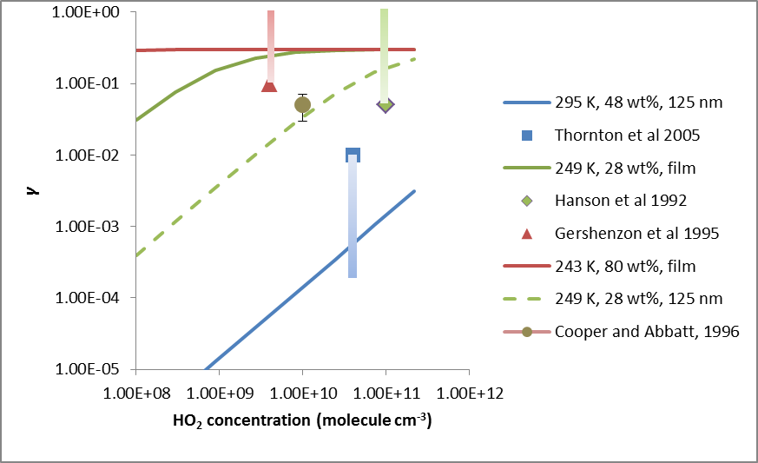

**Figure 1:** Uptake coefficient of HO2 on sulfuric acid as a function of HO2 concentration. Symbols: data, with the lighter end of the vertical bars indicating the upper or lower limit for part of the data points; lines: *γ* based on Equation (2).