IUPAC Task Group on Atmospheric Chemical Kinetic Data Evaluation
– Data Sheet AQ_TH1_OH_4
Datasheets can be downloaded for personal use only and must not be retransmitted or disseminated either electronically or in hardcopy without explicit written permission.
The citation for this datasheet is: IUPAC Task Group on Atmospheric Chemical Kinetic Data Evaluation, http://iupac.pole-ether.fr.
This datasheet last evaluated: May 2017; last change in preferred values: May 2017

OH·(aq) + (COOH)₂(aq) → ·OOC-COOH(aq) + H₂O (1)
OH·(aq) + ⁻OOC-COOH(aq) → ·OOC-COOH(aq)+ OH⁻(aq) (2)
OH·(aq) + ⁻OOC-COO⁻(aq) → ·OOC-COO⁻(aq) + OH⁻(aq) (3)

ΔG_{R}° (aq): Aqueous phase thermochemical data not available. Gas phase data for comparison also not available.

Rate coefficient data

k/ L mol⁻¹ s⁻¹ | T/K | pH | I/ mol L⁻¹ | Reference | Technique/ Comments
Relative Rate Coefficients
k_{1/2} = 3.2 × 10⁷ |  | 2 |  | Scholes and Willson, 1967 |  | PR-UV/Vis (a)
k₁ = (1.0 ± 0.1) × 10⁶ |  | 0.5 |  | Getoff et al., 1971 |  | PR-UV/Vis (b)
k₂ = (3.2 ± 0.1) × 10⁷ |  | 3
k₃ = (5.3 ± 0.3) × 10⁶ |  | 6
k₁ = 1.4 × 10⁶ | 298 | 0.5 |  | Buxton et al., 1988 |  | Recalculated value (c)
k₂ = 4.7 × 10⁷ | 298 | 3
k₃ = 7.7 × 10⁶ | 298 | 6
k₂ = (1.9 ± 0.6) × 10⁸ | 298 | 3 |  | Ervens et al., 2003 |  | LP(d)
k₂ = 2.5 × 10¹² exp[(-2800 ± 500)/T] | 288 - 328
k₃ = (1.6 ± 0.6) × 10⁸ | 298 | 8
k₃ = 4.6 × 10¹⁴ exp[(-4300 ± 1200)/T] | 288 - 328
Absolute Rate Coefficients
k₂ = (5.0 ± 0.5) × 10⁷ |  | 2.5 – 3.5 |  | Ershov et al., 2008 |  | PR - UV/Vis(e)
k₃ = (1.5 ± 0.2) × 10⁷ |  | 6.9 – 7.4 |  | Ershov et al., 2008 |  | PR-UV/Vis(f)

Comments

(a) The molar extinction coefficient of thymine was determined to be ε _{264nm} = 7950 ± 50 over the pH range 1.2 - 7.8. Aerated solutions of thymine (8 × 10⁻⁵ M) were irradiated. Reference reaction: ·OH + Thymine with k(·OH + Thymine) = 4.3 × 10⁹ M⁻¹ s⁻¹.

(b) PR of N₂O-, or Argon-saturated solutions; [(COO⁻)₂] = (0.6 - 10) × 10⁻³ M; Reference reaction: ·OH + SCN⁻ with k(·OH + SCN⁻) = 7.5 × 10⁹ M⁻¹ s⁻¹; pK_{a} values which were given in Getoff et al. (1971) and Buxton et al. (1988) are in good agreement with those from Lide (1996) (1.23, respectively 4.19).

(c) Buxton et al. recalculated the rate constants determined by Getoff et al. (1971) relative to the selected rate constant for the reference reaction k(·OH + SCN⁻) = 1.1 × 10¹⁰ M⁻¹ s⁻¹.

(d) RR; hydrogen peroxide photolysis (λ = 248 nm); pH was adjusted with HClO₄; Reference reaction: ·OH + SCN⁻; Rate constant of the reference reaction is given by k(T) = 7.26 × 10¹² exp[(-1900 ± 190) / T] M⁻¹s⁻¹ referring to Chin and Wine (1992).

(e) PR of N₂O- or Argon-saturated solutions; c(Na₂(COO)₂) = 2 x 10⁻² M; reaction was observed spectroscopically at 250 nm.

(f) PR of N₂O- or Argon-saturated solutions; c((COO⁻)₂) = 5 x 10⁻³ M; The radical anion ·OOC-COO⁻ exhibits absorption that monotonically increases on going to 220 nm (ε _{220nm} = 1800 L mol^{–1} cm^{–1}).

Preferred Values

Parameter | Value | T/K
k₁ /L mol⁻¹ s⁻¹ | k₁ = 1.4 × 10⁶ | 298
k₂ / L mol⁻¹ s⁻¹ | k₂ = 1.0× 10⁸ | 298
k₃ / L mol⁻¹ s⁻¹ | k₃ = 6 × 10⁷ | 298

Reliability
Δ log k₁ | ± 0.11 | 298
Δ log k₂ | ± 0.30 | 298
Δ log k₃ | ± 0.20 | 298

Comments on Preferred Values

Available rate constants are largely scattered. Therefore, only room temperature rate constants are recommended as follows: For k₁ (the undissociated oxalic acid reaction) the recommendation is the value of Buxton et al. (1988). For k₂ (oxalate mono-anion) the recommended value is the average of the room temperature rate constants given by Buxton et al. (1988) and Ervens et al. (2003). For the oxalate dianion reaction (k₃), the recommended value is the average of the data by Buxton et al. (1988), Ervens et al. (2003) and Ershov et al (2007). The relative errors of the average recommended rate constants is estimated to ± 20 %, ± 50 % and ± 30 % for k₁, k₂ and k₃, respectively. No T-dependence is currently recommended. Overall, based on the currently existing kinetic data for this set of OH reactions further measurements appear to be required to better resolve the existing discrepancies.

References

Buxton, G. V., Greenstock, C. L., Helman, W. P. and Ross, A. B.: J. Phys. Chem. Ref. Data, 12(2), 513 – 886, 1988.

Chin, M. and Wine, P. H: J. Photochem. Photobiol., A, 69(1), 17-25, 1992.

Ervens, B., Gligorovski, S. and Herrmann, H.: Phys. Chem. Chem. Phys., 5(9), 1811-1824, 2003.

Ershov, B. G., Janata, E., Alam, M. S., Gordeev, A. V.: High Energ. Chem., 42 (1), 1 - 6, 2008.

Ershov, B. G., Janata, E., Alam, M. S. and Gordeev, A. V., Russ. Chem. Bull., 57(6), 1187-1189, 2008.

Getoff, N., Schwoerer, F., Markovic, V. M., Nielsen, S. O. and Sehested, K.: J. Phys. Chem., 75(6), 749 - 755, 1971.

Lide, D.R.: “CRC Handbook of Chemistry and Physics”, 76th Ed., CRC Press, Boca Raton, 1996.

Scholes, G. and Willson, R.L.: Trans. Faraday Soc., 63, 2983-2993, 1967.

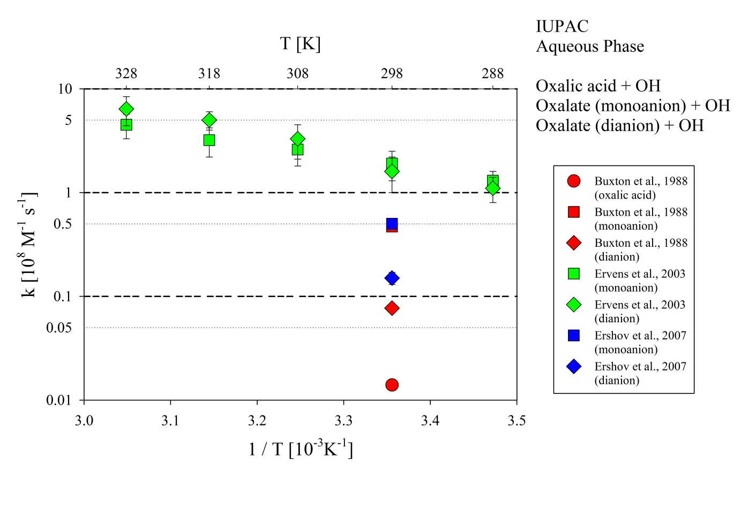
Figure 1: T-dependent rate constants for the reaction of Oxalic acid (monoanion and dianon, respectively) with OH in aqueous solution. Data taken from Buxton et al. (1988), Ervens et al. (2003) and Ershov et al (2007).

