IUPAC Task Group on Atmospheric Chemical Kinetic Data Evaluation
– Data Sheet AQ_TH1_NO3_2
Datasheets can be downloaded for personal use only and must not be retransmitted or disseminated either electronically or in hardcopy without explicit written permission.
The citation for this datasheet is: IUPAC Task Group on Atmospheric Chemical Kinetic Data Evaluation, http://iupac.pole-ether.fr.

This datasheet last evaluated: May 2017; last change in preferred values: June 2016

NO₃·(aq) + CH₂(OH)COOH(aq) → ·CH(OH)COOH(aq) + HNO₃ (1)
NO₃·(aq) + CH₂(OH)COO⁻(aq) → ·CH(OH)COO⁻(aq) + HNO₃ (2)

ΔG_{R}° (aq): Aqueous phase thermochemical data not available. Gas phase data are also not available.

Rate coefficient data

k/ L mol⁻¹ s⁻¹ | T/K | pH | I/ mol L⁻¹ | Reference | Technique/ Comments
Absolute Rate Coefficients
k₁ = (9.1 ± 2.3) × 10⁵ | 298 | 0.5 | 0.45 | de Semainville et al., 2007 |  | LFP(a)
k₁ = 4.5 × 10¹¹ exp[(-3969 ± 1680)/T]
k₂ = (1.0 ± 0.2) × 10⁷ | 298 | 6 | 0.13
k₂ = 1.8 × 10¹¹ exp[(-3007 ± 1080)/T]

Comments

- NO₃ radicals were produced by laser flash photolysis of S₂O₈²⁻ anions (λ = 351 nm). The pH (0.5 and 6) was adjusted by adding HClO₄. Analysis light at λ = 632.8 nm; pK_{a} value for Glycolic acid can be found in Lide (1996) (pK_{a} = 3.83).

Preferred Values

Parameter | Value | T/K
k₁ / L mol⁻¹ s⁻¹ | 9.1 × 10⁵ | 298
k₁(T) / L mol⁻¹ s⁻¹ | 4.5 × 10¹¹ exp[(-3969)/T] | 278 – 318 K
k₂ / L mol⁻¹ s⁻¹ | 1.0 × 10⁷ | 298
k₂(T) / L mol⁻¹ s⁻¹ | 1.8 × 10¹¹ exp[(-3007)/T] | 278 – 318 K

Reliability
Δ log k₁ | ± 0.13 | 298
Δ E_{A1}/R | ± 1700 | 278 – 318
Δ log k₂ | ± 0.10 | 298
Δ E_{A2}/R | ± 1100 | 278 - 318

Comments on Preferred Values

The recommended values are from the currently only available study on these reactions. The activation energies carry considerable error.

References

Lide, D.R.: “CRC Handbook of Chemistry and Physics”, 76th Ed., CRC Press, Boca Raton, 1996.
Gaillard de Semainville, Ph., Hoffmann, D., George, Ch. and Herrmann, H.: Phys. Chem. Chem. Phys., 9, 958 - 968, 2007.
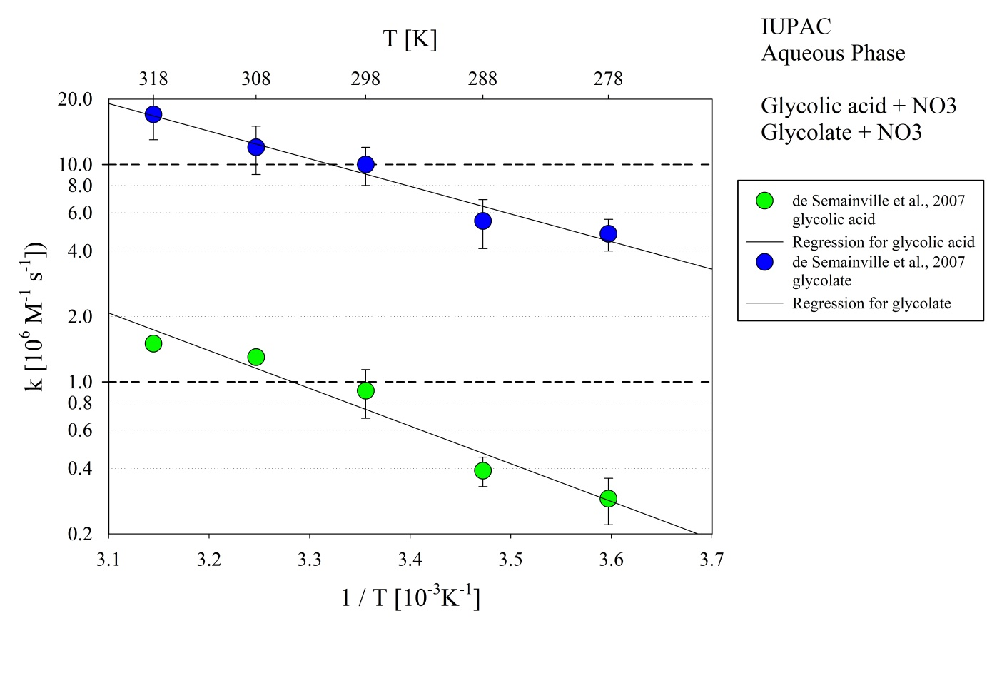
Figure 1: T-dependent rate constants for the reaction of glycolic acid and glycolate with OH in aqueous solution. Data from de Semainville et al. (2007).

