IUPAC Task Group on Atmospheric Chemical Kinetic Data Evaluation
– Data Sheet AQ_TH1_NO3_1
Datasheets can be downloaded for personal use only and must not be retransmitted or disseminated either electronically or in hardcopy without explicit written permission.
The citation for this datasheet is: IUPAC Task Group on Atmospheric Chemical Kinetic Data Evaluation, http://iupac.pole-ether.fr.

This datasheet last evaluated: May 2017; last change in preferred values: June 2016

NO₃·(aq) + [CH(OH)₂]₂(aq) → ·C(OH)₂COOH + HNO₃

ΔG_{R}° (aq): Aqueous phase thermochemical data not available
Gas phase data are also not available because of the hydration of glyoxal.

Rate coefficient data

k/ L mol⁻¹ s⁻¹ | T/K | pH | I/ mol L⁻¹ | Reference | Technique/ Comments
Absolute Rate Coefficients
(4.5 ± 0.3) × 10⁶ | 298 | 6 |  | Schaefer et al., 2015 |  | LFP(a)
6.22 × 10¹² exp[(-4210 ± 1200)/T] | 278 -313

Comments
- A modified thermostated laser flash photolysis-differentially amplified laser long path absorption setup was used; 1 × 10⁻³ M Glyoxal; detection of NO₃ radicals at λ = 442 nm. The reaction of glyoxal with these radicals (SO₄⁻, NO₃, OH) appear to be pH independent.
The rate constants obtained here are comparable with those of other mono- and polyfunctional alcohols (with reference to Hoffmann et al., 2009).

General:
Glyoxal is completely hydrated in aqueous solution. Equilibrium constants for the first and the second hydration of Glyoxal can be found in Ervens et al. (2010): K_{hydr1} = 350, respectively K_{hydr2} = 207.

CHOCHO(aq) + H₂O(l) → CHOCH(OH)₂(aq) with K_{hydr1}
CHOCH(OH)₂(aq) + H₂O(l) → [CH(OH)₂]₂(aq) with K_{hydr2}

Preferred Values

Parameter | Value | T/K
k / L mol⁻¹ s⁻¹ | 4.5 × 10⁶ | 298
k(T) / L mol⁻¹ s⁻¹ | 6.22 × 10¹² exp[-(4210)/T] | 278 - 313

Reliability
Δ log k | ± 0.03 | 298
Δ E_{A}/R | ± 1200 | 278 - 313

Comments on Preferred Values

This is the only available study on NO₃ + glyoxal in aqueous solution.

References

Ervens, B. and Volkamer, R.: Atmos. Chem. Phys., 10 (17), 8219 – 8244, 2010.

Hoffmann, D., Weigert, B., Barzaghi, P. and Herrmann, H.: Phys. Chem. Chem. Phys., 11, 9351 – 9363, 2009.

Schaefer, T., van Pinxteren, D. and Herrmann, H.: Environ. Sci. Technol., 49 (1), 343 – 350, 2015.

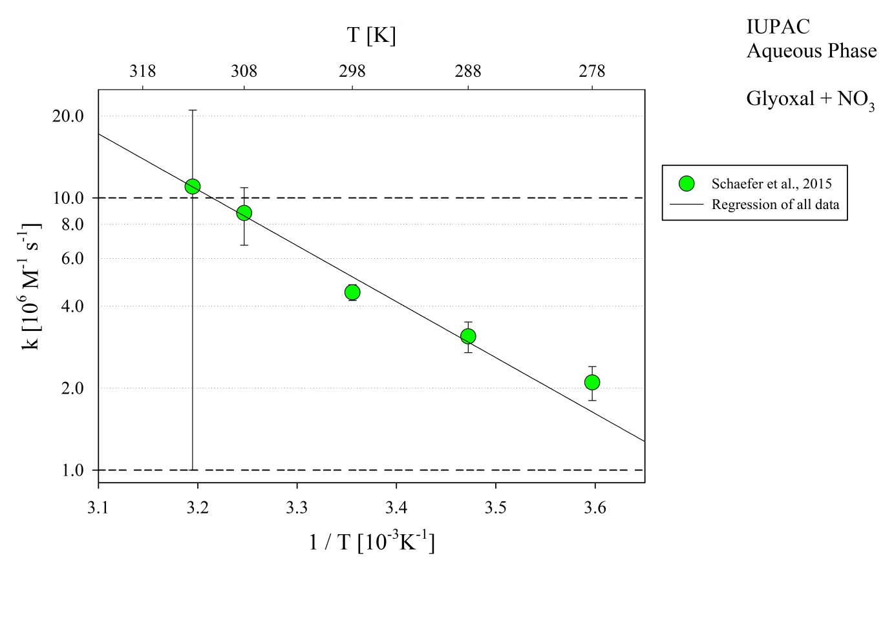
Figure 1: T-dependent rate constants for the reaction of glyoxal with OH in aqueous solution. Data from Schaefer et al. (2015).

