IUPAC Task Group on Atmospheric Chemical Kinetic Data Evaluation
– Data Sheet AQ_OH_90
Datasheets can be downloaded for personal use only and must not be retransmitted or disseminated either electronically or in hardcopy without explicit written permission.
The citation for this datasheet is: IUPAC Task Group on Atmospheric Chemical Kinetic Data Evaluation, http://iupac.pole-ether.fr.
This datasheet last evaluated: November 2019; last change in preferred values: June 2019

H₂CCHCOCH₃(aq) → CH₃(CH)₂CHO(aq) (1)

HO(aq) + H₂CCHCOCH₃(aq) → HOCH₂CHCOCH₃(aq) +
CH₂CH(OH)COCH₃(aq) + H₂O (2)

(primary radical products (2) determined by Kumar et al., 1990; a more detailed discussion of product distribution can be found in Zhang et al., 2010 and Schoene et al., 2014)

Rate coefficient data

 | k/ L mol⁻¹ s⁻¹ | T/K | pH | I/ mol L⁻¹ | Reference |  | Technique/ Comments
 | Absolute Rate Coefficients
7 × 10⁸ |  | 294 | 6.8 | - |  | Kumar et al., 1990 | PR-UV/Vis (a)
 | Relative Rate Coefficients
 | 8.5 × 10⁹ | 294 | - | - | Lilie and Henglein, 1970 |  | PR / UV-Vis (b)
 | 8.5 × 10⁸ | 294 | 6.8 | - | Kumar et al., 1990 |  | PR / UV-Vis (c)
 | 7.1 × 10⁹ | 298 | 7 | - | Szeremeta et al., 2009 |  | LP-LPA (d)
 | 1.6 × 10¹⁰ | 298 | 7 | - |  |  | Corrected value (d1)
 | 4.54 × 10¹¹ exp[-(1200 ±70)/T] | 278 - 318 | 7 | - |  |  | LP-LPA (d2)
 | (7.1 ±0.5) × 10⁹ | 298 | - | - | Schoene et al., 2014 |  | LP-LPA (e)
 | 4.37 × 10¹¹ exp[-(1200 ±60)/T] | 278 - 308 | - | - |  |  | LP-LPA (e1)

ΔG_{R}° (aq): Aqueous phase thermochemical data not available. As well, gas phase thermochemical data Η_{R}° (g) are not available.

As observed by Zhang et al. (2010), methyl vinyl ketone (MVK) in aqueous systems tends to isomerize to crotonaldehyde (1) by rearrangement (approx. 14% of dissolved MVK, independent of H₂O₂ or H₂SO₄ addition; studies performed at pH = 4, 283 K; exact mechanism is still to be determined).

Comments

- Kumar et al. verified their determined rate coefficient (c) by observing the build up of the transient species (T₂) of MVK at 310 nm under the same conditions as (c); as no exact temperature is given, T = 294 K is assumed as room temperature.

- HO radicals were generated by irradiation of N₂O saturated solutions; c(N₂O) = 2.5 × 10⁻² M, concentration of the carbonyl compounds was given as “some 10⁻⁴ molar”, concentration of the compound radicals was calculated to be around 10⁻⁵ M; reference reaction: HO + SCN⁻ with k(HO + SCN⁻) = 6.6 × 10⁹ M⁻¹ s⁻¹; rate coefficients have been recalculated using the selected temperature dependence for the reference reaction by Zhu et al.(2003); analysis was performed within a buffered pH range from 5 to 9; Lilie and Henglein determined, that 30% of the nonhydrated compound radical disproportioned to yield the enol and β-alcohol while the rest forms a dimer; as no exact temperature is given, T = 294 K is assumed for room temperature.

(c) Radicals generated by pulse radiolysis of N₂O saturated solutions, formation of (SCN)₂^{·-} species observed at 500 nm; reference reaction: HO + SCN⁻ with no rate coefficient given for reference; c(methyl vinyl ketone) = 4 × 10⁻³ M; rate coefficient was confirmed by direct observation of transient species at 310 nm (see (a), k = 7.0 × 10⁸ M⁻¹s⁻¹); as no exact temperature is given, T = 294 K is assumed for room temperature.

(d) Radicals generated by photolysis of H₂O₂ solution at 248 nm, product detection at 436 nm; reference reaction: HO + SCN⁻ with ln k(T) = (29.614±0.636) - (1900±190)/T M⁻¹ s⁻¹ (according to Chin and Wine (1992)); rate coefficients were recalculated using the selected temperature dependent rate coefficients by Zhu et al., 2003; c(H₂O₂) = 2 × 10⁻⁵ M, c(KSCN) = 1 × 10⁻⁴ M, c(methyl vinyl ketone) ranging from 5 × 10⁻⁶ to 1 × 10⁻⁴ M; the rate coefficients at 298 K were determined from plotted data, as no specific temperature dependent value was given in the publication; (d1): corrected rate coefficient, calculated by considering simultaneous diffusion and first order chemical reaction, referring to the recalculated k(298 K) value; (d2): Arrhenius expression derives from regression of the corrected recalculated data; activation parameters given in the original publication: A = (8.96 ±2.35) × 10¹¹, E_{A} = (11.90 ±0.64) kJ mol⁻¹; all experiments were repeated eight times for reproducibility.

(e) Radicals generated by photolysis of H₂O₂ solution at 248 nm, for detection, a cw laser was used at 407 nm (laser flash photolysis long-path absorption setup (LP-LPA)); for detection of the carbonyl products formed, derivatization with 2,4-dinitrophenylhydrazine was performed; reference reaction: HO + SCN⁻ with ln k(T) = (29.614±0.636) - (1900±190)/T M⁻¹ s⁻¹ (according to Chin and Wine (1992)); rate coefficients were recalculated using the selected temperature dependence for the reference reaction (Zhu et al., 2003); c(KSCN) = 1.59 × 10⁻⁵ M, c(H₂O₂) = 1 × 10⁻⁴ M; (e1): Arrhenius expression derives from regression of the corrected recalculated data; activation parameters given in the original publication: A = (9.0 ±0.4) × 10¹¹, E_{A} = (12 ±3) kJ mol⁻¹; rate coefficients for k_{313 K} and k_{318 K} were measured, but have not been used to calculate activation parameters.

Preferred Values

Parameter | Value | T/K
k / L mol⁻¹ s⁻¹ | 7.27 × 10⁹ | 298
k / L mol⁻¹ s⁻¹ | 4.72 × 10¹¹ exp[-(1250)/T] | 278 - 308

Reliability
Δ log k | ±0.24 | 298
Δ E_{A}/R | ±250 | 278 – 308

Comments on Preferred Values

Data from Lilie and Henglein (1970), Szeremeta et al. (2009) and Schoene et al. (2014) have been used for regression (r² = 0.94). As the rate coefficients determined by Kumar et al. (1990) differ by a factor of 10 from all other determinations, they have not been considered for the evaluation. While both Szeremeta et al. (2009) and Schoene et al. (2014) determined values in perfect agreement, the rate coefficient of Lilie and Henglein from 1970 implies a higher value. From the regression of the considered data, a rate coefficient of k(298 K) = 7.26 × 10⁹ M⁻¹s⁻¹ is suggested, which is still in perfect agreement with both T dependent determinations within the error limits. The recommendation of k = 8.5 × 10⁹ M⁻¹ s⁻¹ from 1988 by Buxton et al. (without recalculations) considers only the determination by Lilie and Henglein, which explains the deviation to the newly evaluated recommendation. The estimated uncertainty is given as Δ log k = ±0.24 or ±50%.

References

Buxton, G. V., Greenstock, C. L., Helman, W. P. and Ross, A. B.: J. Phys. Chem. Ref. Data, Vol. 12 (2), 513 – 886, 1988.

Chin, M., and Wine, P. H: J. Photochem. Photobiol., A, 69(1), 17-25, 1992.

Kumar, M., Rao, M. H. and Moorthy, P. N.: J. Macromol. Sci., Chem., 27(3), 299-308, 1990.

Lilie, J. and Henglein, A.: Ber. Bunsen-Ges. Phys. Chem., 74(4), 388-393, 1970.

Schöne, L., Schindelka, J., Szeremeta, E., Schaefer, T., Hoffmann, D., Rudzinski, K. J., Szmigielski, R. and Herrmann, H.: Phys. Chem. Chem. Phys., 16(13), 6257-6272, 2014.

Szeremeta, E., Barzaghi, P., Böge, O., Herrmann, H., Gmachowski, L. and Rudzinski, K. J., edt.: Maione, M. and Fuzzi, S., Aracne editrice Srl.: Atmospheric composition Change–Causes and Consequences–Local to Global, 2009.

Zhang, X., Chen, Z. M. and Zhao, Y.: Atmos. Chem. Phys., 10(19), 9551-9561, 2010.

Zhu, L., Nicovich, J. M. and Wine, P. H.: Aquat. Sci., 65(4), 425-435, 2003.
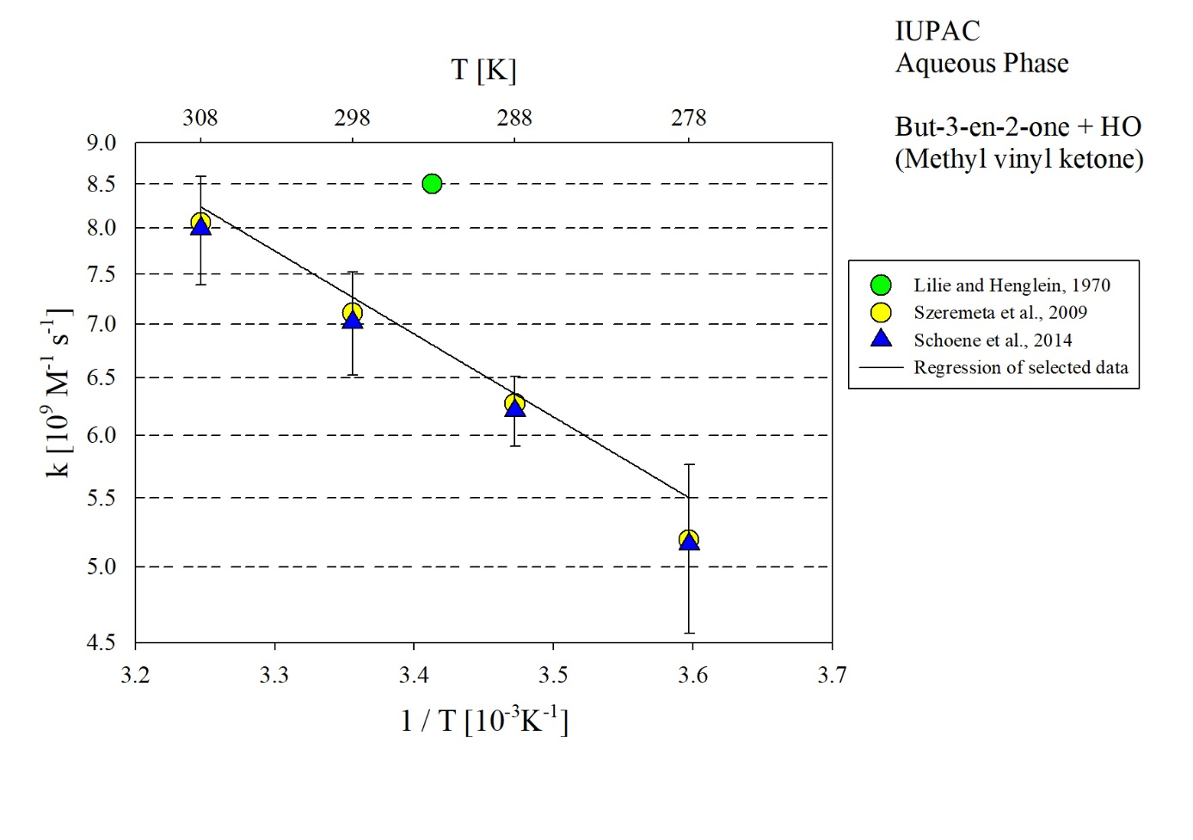
T-dependent rate coefficients for the reaction of methyl vinyl ketone with HO in aqueous solution. Data from Lilie and Henglein (1970), Szeremeta et al. (2009) and Schoene et al. (2014) have been considered for regression. Due to the high deviation, data from Kumar et al. (1990) is not shown.

