IUPAC Task Group on Atmospheric Chemical Kinetic Data Evaluation
– Data Sheet AQ_OH_84
Datasheets can be downloaded for personal use only and must not be retransmitted or disseminated either electronically or in hardcopy without explicit written permission.
The citation for this datasheet is: IUPAC Task Group on Atmospheric Chemical Kinetic Data Evaluation, http://iupac.pole-ether.fr.
This datasheet last evaluated: November 2019; last change in preferred values: June 2019

H₂O + (CH₃)₂CHCH₂COCH₃ (aq) → (CH₃)₂CHCH₂C(OH)₂CH₃ (aq) (1)

HO (aq) + (CH₃)₂CHCH₂COCH₃ (aq) → (CH₃)₂CHCHCOCH₃ (aq)+ H₂O (2)

(product formation taken from Gligorovski et al., 2009)

Rate coefficient data

k/ L mol⁻¹ s⁻¹ | T/K | pH | I/ mol L⁻¹ | Reference | Technique/ Comments
Relative Rate Coefficients
(2.9 ±0.7) × 10⁹ | 298 | 2 | - | Monod et al., 2005 | Dark Fenton / GC-FID (a)
1.25 × 10¹² exp[-(1700 ±330/T)] | 276 - 339 | 2 | - |  | Dark Fenton / GC-FID (a)
(4.41 ±1.5) × 10⁹ | 298 | 6 – 7 | - | Gligorovski et al., 2009 | LFP-LPA (b)
5.0 × 10¹¹ exp[-(1380 ±580/T)] | 278 - 308 | 6 – 7 | - |  | LFP-LPA (b1)

The hydration of methyl isobutyl ketone has not been discussed in the above references, as the influence of hydration of higher carbonyls is neglectable. Following the calculated data of Raventos-Duran (2010) for ketone compounds, it is suggested to assume a value of K_{H} ~ 10⁻³.

ΔG_{R}° (aq): Aqueous phase thermochemical data not available. As well, gas phase thermochemical data Η_{R}° (g) are not available.

Comments

(a) Reference reaction: HO + 2-propanol; k(HO + 2-propanol) = 1.6 × 10⁹ exp[-(5000/R)(1/T – 1/298)] M⁻¹ s⁻¹ (Elliot and Simsons, 1984); for the Fenton-reaction, the initial concentrations of reactants were in the order of 1 × 10⁻³ M; Arrhenius expression for HO + MIBK was given as: ln k(T) = 25.6(±1.0) – [1200(±300)]/T; all rate coefficients have been recalculated using the selected T dependence for the reference reaction k(T) = 1.17 × 10¹¹ exp[-(1180 ±200/T)].

(b) Reference reaction: HO + SCN⁻, with ln k(HO + SCN⁻) = (29.614±0.636) – (1900±190)/T M⁻¹ s⁻¹ (Chin and Wine, 1992); for the Arrhenius expression (b1), the T-dependent rate constants were taken from the plotted data, as no specific values were given; all rate coefficients have been recalculated using the selected T dependence for the reference reaction by Zhu et al., 2003.

Preferred Values

Parameter | Value | T/K
k / L mol⁻¹ s⁻¹ | 4.39 × 10⁹ | 298
k / L mol⁻¹ s⁻¹ | 4.05 × 10¹¹ exp[-(1300)/T] | 276 - 339

Reliability
Δ log k | ±0.24 | 298
Δ E_{A}/R | ±350 | 276 - 339

Comments on Preferred Values

There are two temperature dependent determinations available for the reaction of MIBK with HO from Monod et al. (2005) and Gligorovski et al. (2009). Both have been used for regression to obtain the preferred values. While the determination of Gligorovski et al. (2009) indicates a slightly higher room temperature rate coefficient, the mean of both data sets results in an Arrhenius expression, that correlates with both their data within error limits. The estimated uncertainty is given as Δ log k = ±0.24 or ±50%.

References

Chin, M. and Wine, P. H: J. Photochem. Photobiol., A, 69(1), 17-25, 1992.

Elliot, A. J. and Simsons, A. S.: Radiat. Phys. Chem. (1977), 24(2), 229-231, 1984.

Gligorovski, S., Rousse, D., George, C. H. and Herrmann, H.: Int. J. Chem. Kinet., 41(5), 309-326, 2009.

Monod, A., Poulain, L., Grubert, S., Voisin, D. and Wortham, H.: Atmos. Env., 39(40), 7667-7688, 2005.

Raventos-Duran, T., Camredon, M., Valorso, R., Mouchel-Vallon, C. and Aumont, B.: Atmos. Chem. Phys., 10(16), 7643-7654, 2010.

Zhu, L., Nicovich, J. M. and Wine, P. H.: Aquat. Sci., 65(4), 425-435, 2003.

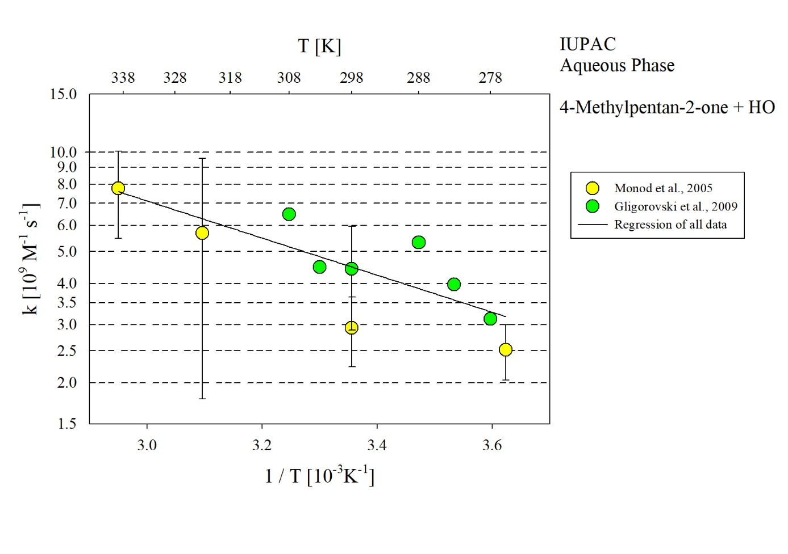
T-dependent rate constants for the reaction of 4-methylpentan-2-one with HO radicals in aqueous solution. All data given in the plot have been used for regression.

