IUPAC Task Group on Atmospheric Chemical Kinetic Data Evaluation
– Data Sheet AQ_OH_80
Datasheets can be downloaded for personal use only and must not be retransmitted or disseminated either electronically or in hardcopy without explicit written permission.
The citation for this datasheet is: IUPAC Task Group on Atmospheric Chemical Kinetic Data Evaluation, http://iupac.pole-ether.fr.
This datasheet last evaluated: November 2019; last change in preferred values: June 2019

H₂O + CH₃COCH₃(aq) → CH₃C(OH)₂CH₃(aq) (1)

HO(aq) + CH₃COCH₃(aq) → CH₃COCH₂(aq) + H₂O (2)

Rate coefficient data

k/ L mol⁻¹ s⁻¹ | T/K | pH | I/ mol L⁻¹ | Reference | Technique/ Comments
Absolute Rate Coefficients
(1.3 ±0.1) × 10⁸ | 298 | 5.8 | - | Hesper, 2003 | LP-LPA (a)
8.4 × 10¹⁰ exp[(-1900 ±330)/T] | 288 - 323 | 6.0 | - |  | LP-LPA (a)
Relative Rate Coefficients
9.7 × 10⁷ | 294 | - | - | Adams et al., 1965 | PR / UV-Vis (b)
8.2 × 10⁷ | 294 | - | - | Thomas, 1965 | PR / UV-Vis (c)
1.3 × 10⁸ | 294 | - | - | Willson et al., 1971 | PR / UV-Vis (d)
(1.3 ±0.1) × 10⁸ | 294 | 6 | - | Wolfenden and Willson, 1982 | PR / UV-Vis (e)
(9.47 ±0.17) × 10⁷ | 294 | 7 | - | Williams et al., 2002 | PR / UV-Vis (f)
(2.0 ±0.6) × 10⁸ | 298 | - | - | Ervens et al., 2003 | LP-LPA (g)
9.6 × 10¹⁰ exp[(-1900±420)/T] | 283 - 318 | - | - |  | LP-LPA (g)
(1.1 ±0.5) × 10⁸ | 298 | 2 | - | Monod et al., 2005 | Dark Fenton / GC-FID (h1)
(1.2 ±0.6) × 10⁸ | 298 | - | - |  | CW / GC-FID (h2)
7.17 × 10¹⁰ exp[-(1900 ±200)/T] | 276 - 323 | - | - |  | CW / GC-FID (h3)
(1.7 ±0.4) × 10⁸ | 298 | 6 - 7 | - | Gligorovski et al., 2009 | WP / UV-Vis (i)

The equilibrium constant for the hydration (1) is recommended as K_{298 K} = 2.0 × 10⁻³ by Doussin and Monod (2013).

ΔG_{R}° (aq): Aqueous phase thermochemical data not available. As well, gas phase thermochemical data Η_{R}° (g) are not available.

Comments

(a) Product formation observed via UV-vis abs. (Long Path Absorption) at 248 nm; direct observation of optical absorption of the peroxyl-radicals formed by the reaction between HO, acetone and O₂; oxygen saturated solutions.

(b) Reference reaction: HO + SCN⁻ with k(HO + SCN⁻) = 6.6 × 10⁹ M⁻¹s⁻¹; recalculation has been performed using the selected value for the reference reaction (1.10 × 10¹⁰ M⁻¹s⁻¹); No exact value is given for the initial concentrations of the reactants. Adams et al. state, that the unexpected low figure for acetone might occur due to the effect of tautomerism in the molecule; as no exact temperature is given, for room temperature T = 294 K is assumed.

(c) Reference reaction: HO + I⁻ with k(HO + I⁻) = (1.02±0.13) × 10¹⁰ M⁻¹s⁻¹; relative rate coefficient given as k(HO + Aceton) / k(HO + I⁻) = (7.5±0.8) × 10⁻³; recalculation has been performed using the selected value for the reference reaction (1.09 × 10¹⁰ M⁻¹s⁻1); no values given for concentrations; as no exact temperature is given, for room temperature T = 294 K is assumed..

(d) Product formation observed via UV-vis-spectroscopy at 410 nm; Reference reaction: HO + [Fe(CN)₆]⁴⁻ with k(HO + [Fe(CN)₆]⁴⁻) = (0.93±0.05) × 10¹⁰ M⁻¹s⁻¹; recalculation has been performed using the selected value for the reference reaction (1.03 × 10¹⁰ M⁻¹s⁻¹); c([Fe(CN)₆]⁴⁻) = 2 × 10⁻³ mol/l ; The reference values listed in Table 1 were recalculated using k(HO + ethanol) = 1.85 × 10⁹ M⁻¹s⁻¹ ; in most reactions air was present or the solutions were saturated with N₂O; as no exact temperature is given, for room temperature T = 294 K is assumed..

(e) Product formation observed via UV-vis-spectroscopy at 415 nm; Reference reaction: HO + ABTS (2,2’-Azinobis-(3-ethylbenzthiazoline-6-sulphonate)); k(HO + ABTS) = 1.2 × 10¹⁰ M⁻¹s⁻¹, c(ABTS) = 1 × 10⁻⁴ mol/l; N₂ and N₂O saturated solutions; as no exact temperature is given, for room temperature T = 294 K is assumed..

(f) Reference reaction: HO + SCN⁻ with k(HO + SCN⁻) = 1.1 × 10¹⁰ M⁻¹s⁻¹; c(SCN⁻) = 0.01 M in N₂O saturated solution; c(acetone) in the range of 10⁻⁴ – 10⁻² mol/l; as no exact temperature is given, for room temperature T = 294 K is assumed..

(g) Reference reaction: HO + SCN⁻; c(thiocyanate) = 2 × 10⁻⁵ mol/l, reference reaction rate constant given by: k(T) = 7.26 × 10¹² exp[(-1900 ± 190) / T] M⁻¹s⁻¹ by Chin and Wine (1992); The measured rate constants were recalculatedusing the new recommended temperature dependence for the reference reaction (Zhu et al., 2003).

(h) Radicals generated by dark Fenton reaction (h1) and continuous photolysis of H₂O₂ (h2); temperature dependent rate constants (h3) were determined using both methods. Reference reaction: HO + methanol; k(T) = 9.7 × 10⁸ exp[-4800/R(1/T-1/298)] (Elliot and Simsons, 1984); recalculation has been performed using the selected temperature dependence for the reference reaction (6.55 × 10¹⁰ exp[-(1250) / T)]); Arrhenius expression (h3) is calculated from experimental data of Monod (2005), but given as ln k(T) = (23.5±1.7) – [1400(±500)]/T in their work, resulting from the combined data of Monod (2005), Ervens et al. (2003) and Buxton et al. (1988).

(i) Radicals generated by flash photolysis in a Teflon AF waveguide photolysis (WP) system; products analysed by UV-Vis abs.; reference reaction: HO + SCN⁻ with ln k(T) = (29.614±0.636) – (1900±190)/T (Chin and Wine, 1992); for the recalculation, the selected T dependence by Zhu et al. (2003) has been used.

Preferred Values

Parameter | Value | T/K
k / L mol⁻¹ s⁻¹ | 1.34 × 10⁸ | 298
k / L mol⁻¹ s⁻¹ | 8.23× 10¹⁰ exp[-(1900)/T] | 276 - 323

Reliability
Δ log k | ±0.15 | 298
Δ E_{A}/R | ±400 | 276 - 323

Comments on Preferred Values

All available data presented in the Table have been used for regression. The resulting rate coefficient agrees with earlier determinations within error limits as well as the recommendation by Buxton et al. (1988), of k = 1.1 × 10⁸ M⁻¹s⁻¹. From the three available T dependent determinations, the data by Ervens et al. (2003) indicates higher values for the rate coefficients, while the Arrhenius expression of Monod et al. (2005) indicates values slightly lower. The mean of them is in perfect agreement with the directly observed T dependent determination by Hesper (2003). The uncertainty of the recommended value is estimated as ±33% or Δ log k = ±0.15.

References

Adams, G.E., Boag, J.W., Currant, J. and Michael, B.D., Pulse Radiolysis, Ebert, M., Keene, J.P., Swallow, A.J. and Baxendale, J.H. (eds.): Academic Press, New York, p.131-143, 1965.

Buxton, G. V., Greenstock, C. L., Helman, W. P. and Ross, A. B.: J. Phys. Chem. Ref. Data, 12(2), 513 – 886, 1988.

Chin, M. and Wine, P. H: J. Photochem. Photobiol., A, 69(1), 17-25, 1992.

Doussin, J. F. and Monod, A.: Atmos. Chem. Phys., 13(23), 11625-11641, 2013.

Elliot, A. J. and Simsons, A. S.: Radiat. Phys. Chem. (1977), 24(2), 229-231, 1984.

Ervens, B., Gligorovski, S. and Herrmann, H.: Phys. Chem. Chem. Phys., 5(9), 1811-1824, 2003.

Gligorovski, S., Rousse, D., George, C. H. and Herrmann, H.: Int. J. Chem. Kinet., 41(5), 309-326, 2009.

Hesper, J.: Ph.D. Dissertation, University of Leipzig, Leipzig, Germany, 2003.

Monod, A., Poulain, L., Grubert, S., Voisin, D. and Wortham, H.: Atmos. Env., 39(40), 7667-7688, 2005.

Thomas, J. K.: Trans. Faraday Soc., 61, 702-707, 1965.

Williams, J. A., Cooper, W. J., Mezyk, S. P. and Bartels, D. M.: Radiat. Phys. Chem., 65(4), 327-334, 2002.

Willson, R. L., Greenstock, C. L., Adams, G. E., Wageman, R., and Dorfman, L. M.: Int. J. Radiat. Phys. Chem., 3(3), 211-220, 1971.

Wolfenden, B. S. and Willson, R. L.: J. Chem. Soc., Perkin Trans. 2, (7), 805-812, 1982.

Zhu, L., Nicovich, J. M. and Wine, P. H.: Aquat. Sci., 65(4), 425-435, 2003.

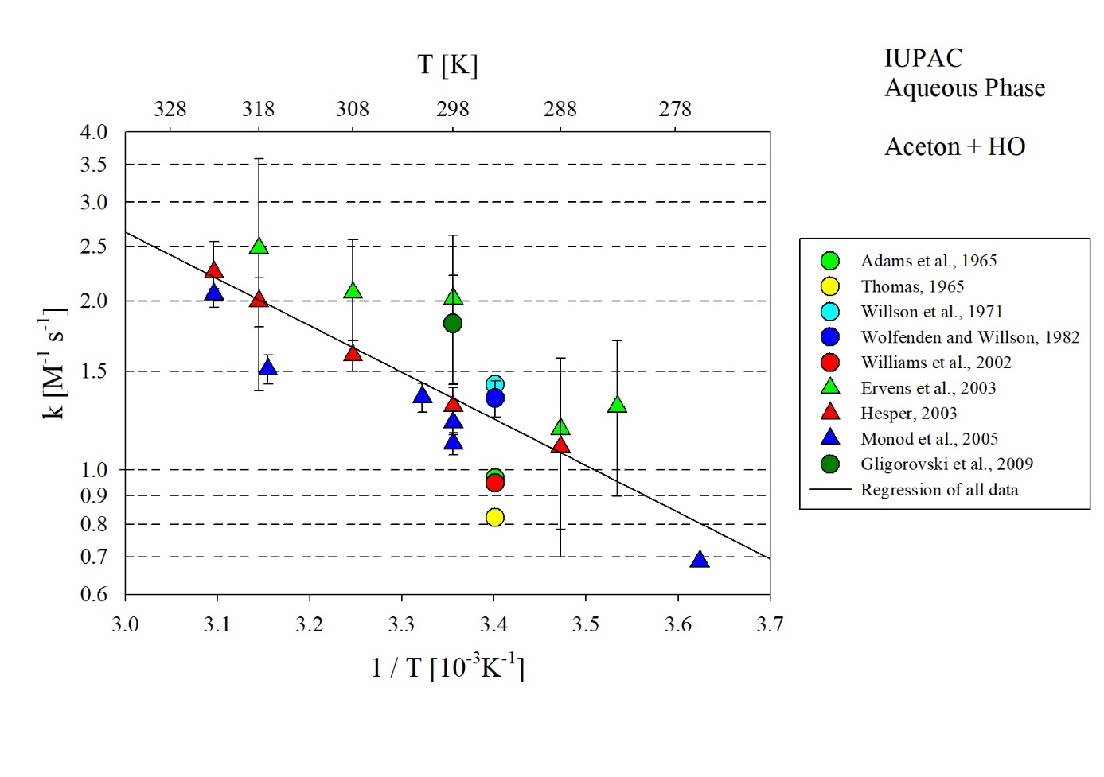
T-dependent rate constants for the reaction of acetone with HO in aqueous solution. Regression uses all data plotted in the figure.

