IUPAC Task Group on Atmospheric Chemical Kinetic Data Evaluation
– Data Sheet AQ_OH_71
Datasheets can be downloaded for personal use only and must not be retransmitted or disseminated either electronically or in hardcopy without explicit written permission.
The citation for this datasheet is: IUPAC Task Group on Atmospheric Chemical Kinetic Data Evaluation, http://iupac.pole-ether.fr.
This datasheet last evaluated: June 2019; last change in preferred values: June 2019

HO(aq) + CH₂CCH₃CHO → CH₃COCH₂OH (16.2%)
+ CH₃COCHO (9.9%)
+ CHOCH₂OH (5.1%)

(Product distribution taken from Schoene et al., 2014; a more extensive product study is discussed in this publication)

Rate coefficient data

k/ L mol⁻¹ s⁻¹ | T/K | pH | I/ mol L⁻¹ | Reference | Technique/ Comments
Absolute Rate Coefficients
(8.0 ±0.7) × 10⁹ | 293 | 4 | - | Buxton et al., 2000 | PR / LP / UV-Vis (a)
Relative Rate Coefficients
9.81 × 10⁹ | 298 | 7 | - | Szeremeta et al., 2007 | LP-LPA (b)
4.46 × 10¹⁰ | 298 | 7 | - |  | Corrected value (b1)
3.34 × 10¹¹ exp[-(1100 ±200)/T] | 278 - 318 | - | - |  | LP-LPA (b2)
(1.4 ±0.3) × 10¹⁰ | 298 | - | - | Gligorovski et al., 2009 | LP-LPA (c)
2.7 × 10¹³ exp[-(2260 ±100)/T] | 278 – 318 | - | - |  | LP-LPA (c)
(5.5 ±0.9) × 10⁹ | 279 | - | - | Liu et al., 2009 | cw (d)
(9.0 ±0.7) × 10⁹ | 298 | - | - | Schoene et al., 2014 | LP-LPA (e)
2.5 × 10¹¹ exp[-(1000 ±270)/T] | 278 - 318 | - | - |  | LP-LPA (e1)

ΔG_{R}° (aq): Aqueous phase thermochemical data not available. As well, gas phase thermochemical data Η_{R}° (g) are not available.

Comments

- Product formation observed at 250 nm; c(methacrolein) = 2.4 × 10⁻⁵ to 18 × 10⁻⁵ M; N₂O saturated solutions, product spectrums were taken from a 5.5 × 10⁻⁴ M solution of methacrolein, 3 µs after the pulse.

- Radicals generated by photolysis of H₂O₂ solution at 248 nm, product detection at 436 nm; reference reaction: HO + SCN⁻ with ln k(T) = (29.614±0.636) - (1900±190)/T M⁻¹ s⁻¹ (according to Chin and Wine (1992)); for the recalculation, the selected temperature dependence by Zhu et al. (2003) has been used; c(H₂O₂) = 2 × 10⁻⁵ M, c(KSCN) = 1 × 10⁻⁴ M, c(methacrolein) ranging from 5 × 10⁻⁶ to 1 × 10⁻⁴ M; the rate constants at 298 K were determined from plotted data, as no specific temperature dependent value was given in the publication; (b1): corrected rate constant, calculated by considering simultaneous diffusion and first order chemical reaction; (b2): Arrhenius expression was calculated using the given activation parameters; all experiments were repeated eight times for reproducibility; pH is given as neutral.

- Radicals generated by photolysis of H₂O₂ solution at 248 nm in a Teflon waveguide photolysis system; reference reaction: HO + SCN⁻ with ln k(T) = (29.614±0.636) - (1900±190)/T M⁻¹ s⁻¹ (according to Chin and Wine (1992)); for the recalculation, the selected temperature dependence by Zhu et al. (2003) has been used.

- Radicals generated by continuous wave photolysis of H₂O₂ solutions as described in Monod et al.(2000), products were analyzed by HPLC-UV at 360 nm; reference reaction: HO + 1-propanol with k(279 K)(HO + 1-propanol) = (2.7 ±0.7) × 10⁹ M⁻¹ s⁻¹ (determined by Monod et al., 2005); for the recalculation, the selected rate coefficient for the reference reaction (k(279 K) = 2.56 × 10⁹ M⁻¹ s⁻¹) has been used; experiments were performed in unbuffered solutions; c(H₂O₂) = 8.0 × 10⁻³ M, c(methacrolein) = 5.0 × 10⁻⁵ M, c(1-PrOH) = 1.0 × 10⁻⁴ M;

- Radicals generated by photolysis of H₂O₂ solution at 248 nm, for detection, a cw laser was used at 407 nm (laser flash photolysis long-path absorption setup (LP-LPA)); reference reaction: HO + SCN⁻ with ln k(T) = (29.614±0.636) - (1900±190)/T M⁻¹ s⁻¹ (according to Chin and Wine (1992)); for the recalculation, the selected temperature dependence by Zhu et al. (2003) has been used; c(KSCN) = 1.59 × 10⁻⁵ M, c(H₂O₂) = 1 × 10⁻⁴ M; Arrhenius expression was calculated from the given activation parameters (e1).

Preferred Values

Parameter | Value | T/K
k / L mol⁻¹ s⁻¹ | 9.68 × 10⁹ | 298
k / L mol⁻¹ s⁻¹ | 1.98 × 10¹² exp[-(1600)/T] | 278 - 318

Reliability
Δ log k | ±0.24 | 298
Δ E_{A}/R | ±400 | 278 - 318

Comments on Preferred Values

Data from Buxton et al. (2000), Szeremeta et al. (2007), Gligorovski et al. (2009), Liu et al. (2009) and Schoene et al. (2014) have been used for regression. Both the temperature dependent and the room temperature data show considerable scatter around a factor of two. While the T dependent determination by Gligorovski et al. (2009) indicate a higher rate coefficient, the directly observed data from Buxton et al. (2000) as well as the rate coefficient determined by Liu et al. (2009) agree quite well with the T dependences from Szeremeta et al. (2007) and Schöne et al. (2014). For the recommended rate constant as a function of temperature, the mean of all determinations is suggested. The estimated uncertainty is estimated as Δ log k = ±0.24 or ±50%.

References

Buxton, G. V., Salmon, G. A. and Williams, J. E.: J. Atmos. Chem., 36(2), 111-134, 2000.

Chin, M., and Wine, P. H: J. Photochem. Photobiol., A, 69(1), 17-25, 1992.

Gligorovski, S., Rousse, D., George, C. H. and Herrmann, H.: Int. J. Chem. Kinet., 41(5), 309-326, 2009.

Liu, Y., Haddad, I. E., Scarfogliero, M., Nieto-Gligorovski, L., Temime-Roussel, B., Quivet, E. and Monod, A.: Atmos. Chem. Phys., 9(14), 5093-5105, 2009.

Monod, A., Chebbi, A., Durand-Jolibois, R. and Carlier, P.: Atmos. Environ., 34(29), 5283-5294, 2000.

Schöne, L., Schindelka, J., Szeremeta, E., Schaefer, T., Hoffmann, D., Rudzinski, K. J., Szmigielski, R. and Herrmann, H.: Phys. Chem. Chem. Phys., 16(13), 6257-6272, 2014.

Szeremeta, E., Barzaghi, P., Böge, O., Herrmann, H., Gmachowski, L. and Rudzinski, K. J., edt.: Maione, M. and Fuzzi, S., Aracne editrice Srl.: Procedings of the Second ACCENT Symposium, 2007.

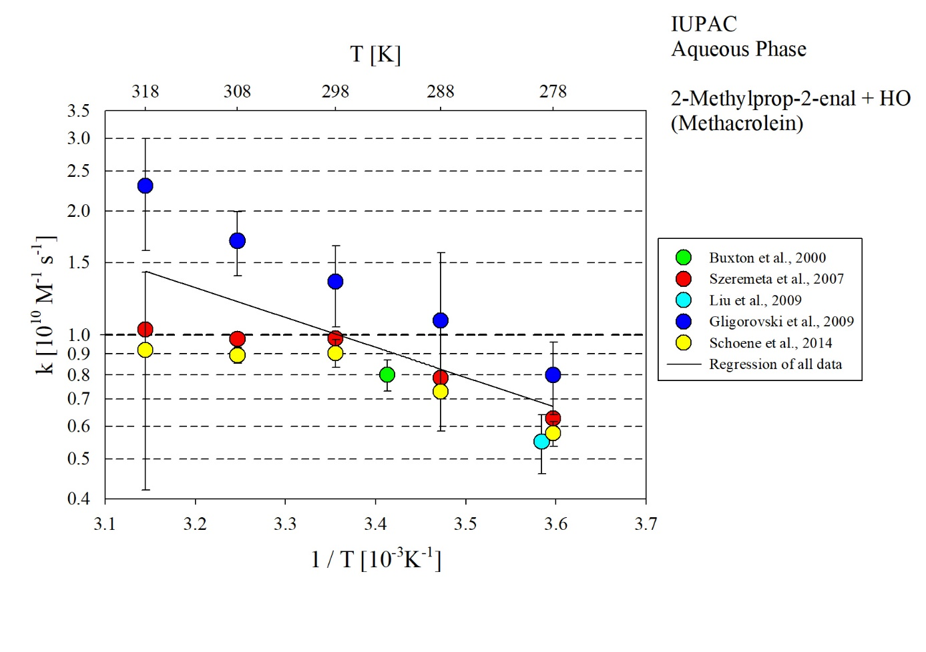
T-dependent rate coefficients for the reaction of methacrolein with HO radicals in aqueous solution. For the regression, all data given in the plot has been considered.

