IUPAC Task Group on Atmospheric Chemical Kinetic Data Evaluation
– Data Sheet AQ_OH_64
Datasheets can be downloaded for personal use only and must not be retransmitted or disseminated either electronically or in hardcopy without explicit written permission.
The citation for this datasheet is: IUPAC Task Group on Atmospheric Chemical Kinetic Data Evaluation, http://iupac.pole-ether.fr.
This datasheet last evaluated: November 2019; last change in preferred values: June 2019

H₂O + (CH₃)₂CHCHO (aq) → (CH₃)₂CHCH(OH)₂ (aq) (1)

HO (aq) + (CH₃)₂CHCHO (aq) → products (2)
HO (aq) + (CH₃)₂CHCH(OH)₂ (aq) → products (3)

Rate coefficient data

k/ L mol⁻¹ s⁻¹ | T/K | pH | I/ mol L⁻¹ | Reference | Technique/ Comments
Relative Rate Coefficients
2.6 × 10⁹ | 294 | 7 | - | Acero et al., 2001 | Competition kinetics / HPLC (a)
(2.8 ±1.0) × 10⁹ | 298 | - | - | Gligorovski and Herrmann, 2004 | LP-LPA (b)
1.4 × 10¹⁰ exp[(-500±100)/T] | 288 - 328 | - | - |  | LP-LPA (b)
(2.8 ±1.5) × 10⁹ | 298 | - | - | Moise et al., 2005 | LCW / photolysis (c)
2.3 × 10⁹ | 298 | - | - | Jürgens et al., 2007 | CFSR / HRGC (d)

The equilibrium constant for the hydration (1) is recommended as K_{298 K} = 0.50 by Doussin and Monod (2013).

ΔG_{R}° (aq): Aqueous phase thermochemical data not available. As well, gas phase thermochemical data Η_{R}° (g) are not available.

Comments

(a) HO radicals were generated by addition of O₃ (0.25 – 5 mg/L) to the aqueous solution; products analyzed by HPLC. Reference reaction: HO + pCBA with k(HO + pCBA) = 5 × 10⁹ M⁻¹s⁻¹ (recommendation by Buxton et al., 1988); the rate coefficient has been recalculated using the recommended value for the reference reaction k = 4.64 × 10⁹ M⁻¹s⁻¹; Indigo method, as described by Bader and Hoigné (1981) was used for analyzing dissolved ozone; as no exact temperature is given, T = 294 K is assumed for room temperature.

(b) The overall reactions of the aldehyde and its hydrate were investigated; reference reaction: HO + SCN⁻ with k(HO + SCN⁻) = 1.24 × 10¹⁰ M⁻¹s⁻¹ as determined by Chin and Wine (1992); the rate coefficient has been recalculated using the recommended values for the temperature dependent reference reaction by Zhu et al. (2003); 39% of the aldehyde is considered to be in hydrate form, with K_{H}(298 K) = 0.64, according to Pocker and Dickerson (1969).

(c) HO radicals were generated by photolysis of H₂O₂ (aq) within a liquid core waveguide (LCW); reference reaction: HO + SCN⁻ with k(HO + SCN⁻) = 1.24 × 10¹⁰ M⁻¹s⁻¹ as determined by Chin and Wine (1992); the rate coefficient has been recalculated using the recommended value for the reference reaction k = 1.19 × 10¹⁰ M⁻¹s⁻¹; c(isobutyraldehyd) = 1 × 10⁻⁴ - 5 × 10⁻⁴ M; c(SCN⁻) = 4 × 10⁻⁴ M.

(d) HO radicals were generated by UV irradiation of H₂O₂(aq) at 254 nm, reactions were performed in a continuous flow-stirred reactor (CFSR) with flow rate of 250 mL min⁻¹; c(sample) = 2 – 10 mg L⁻¹, c(H₂O₂) = 70 – 107 mg L⁻¹, products were analyzed by high resolution gas chromatography (HRGC) MS and HRGC-FID; the rate coefficients represent the mean of two determinations referring to two different reference reactions (tert-butanol + HO and n-Octanol + HO) without stating the individually determined rate coefficients; no recalculation of the rate coefficient could be performed.

Preferred Values

Parameter | Value | T/K
k / L mol⁻¹ s⁻¹ | 2.75 × 10⁹ | 298
k / L mol⁻¹ s⁻¹ | 1.58 × 10¹⁰ exp[-(520)/T] | 288 - 328

Reliability
Δ log k | ±0.09 | 298
Δ E_{A}/R | ±80 | 288 - 328

Comments on Preferred Values

For the recommendation, the determinations by Acero et al. (2001), Gligorovski and Herrmann (2004) and Moise et al. (2005) have been used for the regression of the Arrhenius expression. The rate coefficient by Jürgens et al. (2007) is given as the mean value of two individual determinations. As the single determinations are not given in their work, the data could not be used for the evaluation and therefore has not been considered for the regression, even though the rate coefficient is in agreement with all other determinations within error limits. The estimated uncertainty is given as Δ log k = ±0.09 or ±20%.

References

Acero, J. L., Haderlein, S. B., Schmidt, T. C., Suter, M. J. F. and von Gunten, U.: Environ. Sci. Technol., 35(21), 4252-4259, 2001.

Bader, H. and Hoigné, J.: Water Res., 15(4), 449-456, 1981.

Buxton, G. V., Greenstock, C. L., Helman, W. P. and Ross, A. B.: J. Phys. Chem. Ref. Data, 12(2), 513 – 886, 1988.

Chin, M., and Wine, P. H: J. Photochem. Photobiol., A, 69(1), 17-25, 1992.

Doussin, J. F., and Monod, A.: Atmos. Chem. Phys., 13(23), 11625-11641, 2013.

Gligorovski, S. and Herrmann, H.: Phys. Chem. Chem. Phys., 6(16), 4118-4126, 2004.

Jürgens, M., Jacob, F., Ekici, P., Friess, A. and Parlar, H.: Atmos. Environ., 41(22), 4571-4584, 2007.

Moise, T., Rudich, Y., Rousse, D. and George, C.: Environ. Sci. Technol., 39(14), 5203-5208, 2005.

Pocker, Y. and Dickerson, D. G.: J. Phys. Chem., 73(11), 4005-4012, 1969.

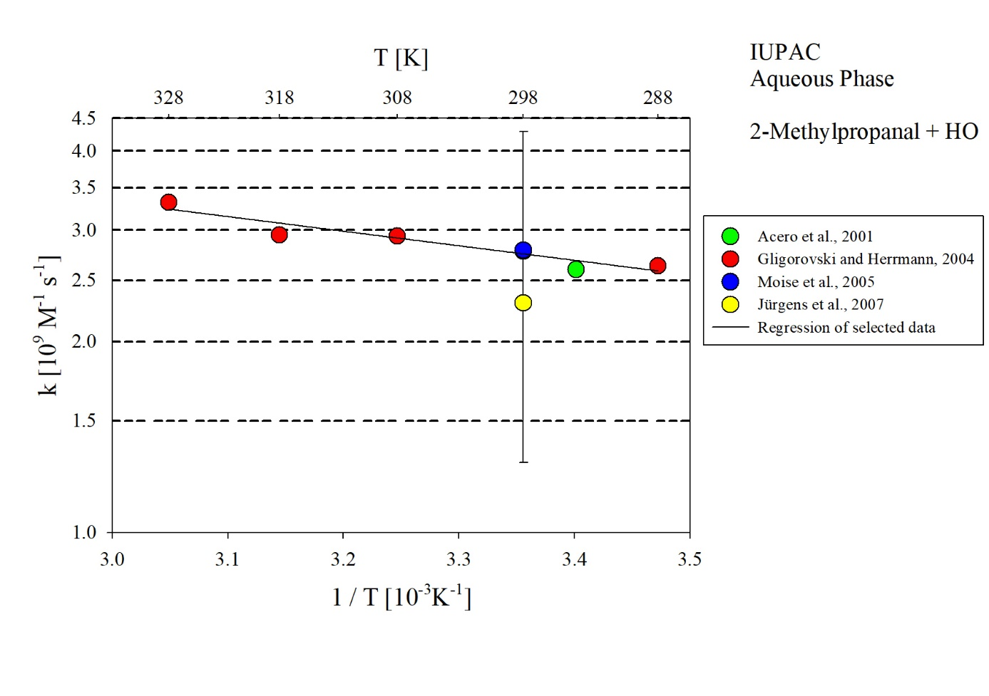
T-dependent rate constants for the reaction of 2-methylpropanal with HO in aqueous solution. The rate coefficient determined by Jürgens et al. (2007) have not been included in the regression.

