IUPAC Task Group on Atmospheric Chemical Kinetic Data Evaluation
– Data Sheet AQ_OH_63
Datasheets can be downloaded for personal use only and must not be retransmitted or disseminated either electronically or in hardcopy without explicit written permission.
The citation for this datasheet is: IUPAC Task Group on Atmospheric Chemical Kinetic Data Evaluation, http://iupac.pole-ether.fr.
This datasheet last evaluated: November 2019; last change in preferred values: June 2019

H₂O + CH₃(CH₂)₂CHO(aq) → CH₃(CH₂)₂CH(OH)₂(aq) (1)

HO(aq) + CH₃(CH₂)₂CHO(aq) → products (2)
HO(aq) + CH₃(CH₂)₂CH(OH)₂(aq) → products (3)

Rate coefficient data

k/ L mol⁻¹ s⁻¹ | T/K | pH | I/ mol L⁻¹ | Reference | Technique/ Comments
Absolute Rate Coefficients
(3.9 ±0.7) × 10⁹ | 298 | 6.2 | - | Hesper, 2003 | LP / LPA (a)
8.1 × 10¹⁰ exp [-(900 ±300)/T] | 288 - 328 | 6.2 | -
Relative Rate Coefficients
3.88 × 10⁹ | 294 | 2 | - | Adams et al., 1965 | PR / UV-Vis (b)
(3.84 ±0.7) × 10⁹ | 298 | 2 | - | Monod et al., 2005 | Fenton reaction (c)

The equilibrium constant for the hydration (1) is recommended as K_{298 K} = 0.60 by Doussin and Monod (2013).

ΔG_{R}° (aq): Aqueous phase thermochemical data not available. As well, gas phase thermochemical data Η_{R}° (g) are not available.

Comments

(a) Direct observation of the peroxyl-radicals at 248 nm, formed by the reaction between HO, butanal and O₂. Reviewed by Herrmann (2003).

(b) Reference reaction: k(HO + SCN⁻) = 6.6 × 10⁹ M⁻¹s⁻¹; a recalculation has been performed using the selected T dependence for the reference reaction by Zhu et al. (2003); no exact value is given for the initial concentrations of the reactants; as no exact temperature is given, a room temperature of 294 K is assumed.

(c) Radicals generated by dark Fenton reaction; Global rate constant for the reaction of HO radicals with butanal (2) and its hydrate (3) has been determined; K_{hyd}(25° C) was considered to be 0.42 (Bell and Evans, 1966); no specific information given on the reference reactions used for the determination; in general, multiple references were used: HO + methanol; k(T) = 9.7 × 10⁸ exp[-4800/R(1/T-1/298)] (Elliot and Simsons, 1984); HO + 2-propanol; k(T) = 1.6 × 10⁹ exp[-5000/R(1/T-1/298)] (Elliot and Simsons, 1984); HO + formaldehyde; k(T) = exp[(23.9±0.29) - (1020±90/T)] (Chin and Wine, 1994).

Preferred Values

Parameter | Value | T/K
k / L mol⁻¹ s⁻¹ | 3.79 × 10⁹ | 298
k / L mol-1 s-1 | 7.23 × 10¹⁰ exp[-(880)/T] | 288 - 328

Reliability
Δ log k | 0.09 | 298
Δ E_{A}/R | ±90 | 288 - 328

Comments on Preferred Values

Since the last recommendation of Buxton et al. in 1988, referring to the rate coefficient by Adams et al. (1965) a temperature dependent study by Hesper (2003) became available. The combined data of both agree well within error limits. The rate coefficient determined by Monod et al. (2005) could not be used for further evaluation, as the publication does not refer to the specific reference reactions. It is assumed, that the value given results from a mean of determinations versus several reference systems. While their determination confirms the data of Hesper (2003), it is therefore not included in the regression for the determination of the preferred value. The estimated uncertainty is given as Δ log k = ±0.09 or ±20%.

References

Adams, G.E., Boag, J.W., Currant, J. and Michael, B.D., Pulse Radiolysis, Ebert, M., Keene, J.P., Swallow, A.J. and Baxendale, J.H. (eds.): Academic Press, New York, 131-143, 1965.

Bell, R. P. and Evans, P. G.: Proc. R. Soc. Lond., Ser. A, 291(1426), 297-323, 1966.

Buxton, G. V., Greenstock, C. L., Helman, W. P. and Ross, A. B.: J. Phys. Chem. Ref. Data, 12(2), 513 – 886, 1988.

Chin, M. and Wine, P. H.: Aquat. Surf. Photochem., 85-96, 1994.

Doussin, J. F. and Monod, A.: Atmos. Chem. Phys., 13(23), 11625-11641, 2013.

Elliot, A. J. and Simsons, A. S.: Radiat. Phys. Chem. (1977), 24(2), 229-231, 1984.

Herrmann, H.: Chem. Rev., 103(12), 4691-4716, 2003.

Hesper, J.: Ph.D. Dissertation, University of Leipzig, Leipzig, Germany, 2003.

Monod, A., Poulain, L., Grubert, S., Voisin, D. and Wortham, H.: Atmos. Env., 39(40), 7667-7688, 2005.

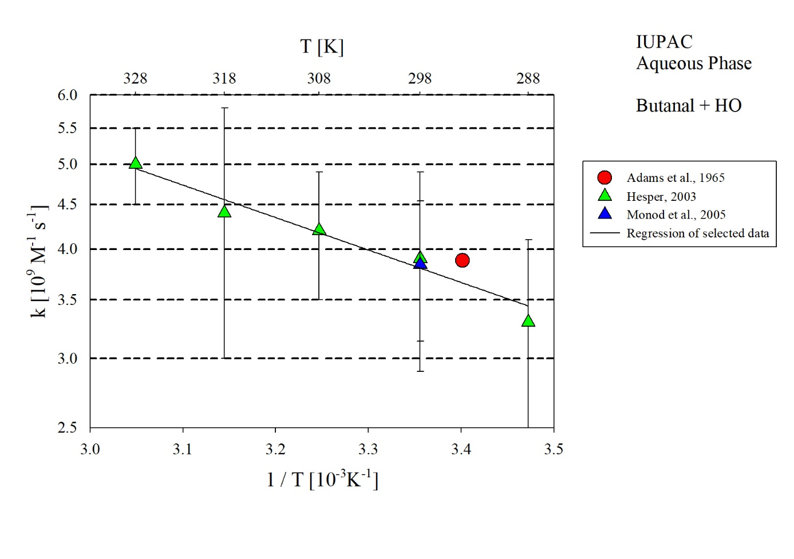
T-dependent rate constants for the reaction of butanal with HO in aqueous solution. Data from Adams et al. (1965) and Hesper (2003) have been used for regression.

