IUPAC Task Group on Atmospheric Chemical Kinetic Data Evaluation
– Data Sheet AQ_OH_62
Datasheets can be downloaded for personal use only and must not be retransmitted or disseminated either electronically or in hardcopy without explicit written permission.
The citation for this datasheet is: IUPAC Task Group on Atmospheric Chemical Kinetic Data Evaluation, http://iupac.pole-ether.fr.
This datasheet last evaluated: November 2019; last change in preferred values: June 2019

H₂O + CH₃CH₂CHO (aq) → CH₃CH₂CH(OH)₂ (aq) (1)

HO (aq) + CH₃CH₂CHO (aq) → products (2)
HO (aq) + CH₃CH₂CH(OH)₂ (aq) → products (3)

Rate coefficient data

k/ L mol⁻¹ s⁻¹ | T/K | pH | I/ mol L⁻¹ | Reference | Technique/ Comments
Absolute Rate Coefficients
(2.8 ± 0.3) × 10⁹ | 298 | 6.1 | - | Hesper, 2003 | LP-LPA (a)
2.6 × 10¹¹ exp[-(1300 ± 300)/T] | 283 - 313 | 6.1 | -
Relative Rate Coefficients
(2.33 ± 0.06) × 10⁹ | 298 | 5.2 | - | Mezyk, 1994 | PR / UV-Vis (b)
8.01 × 10¹³ exp[-(3100 ± 100)/T] | 275 - 310 | 5.2 | - |  | PR / UV-Vis (b)
(3.65 ± 0.5) × 10⁹ | 298 | 2 | - | Monod et al., 2005 | Fenton reaction (c)

The equilibrium constant for the hydration (1) is recommended as K_{298 K} = 0.85 by Doussin and Monod (2013).

ΔG_{R}° (aq): Aqueous phase thermochemical data not available. As well, gas phase thermochemical data Η_{R}° (g) are not available.

Comments

(a) Direct observation of the peroxyl-radicals at 248 nm, formed by the reaction between HO, propanal and O₂. Reviewed by Herrmann (2003).

(b) Reference reaction: HO + SCN⁻ with k(HO + SCN⁻) = 1.22 × 10¹⁰ M⁻¹s⁻¹ according to Chin and Wine (1992); recalculation has been performed using the selected T dependence for the reference reaction by Zhu et al. (2003); experiments were performed in deoxygenated N₂O / N₂ saturated solutions.

(c) Radicals generated by dark Fenton reaction; Global rate constant for the reaction of HO radicals with propanal (2) and its hydrate (3) has been determined; K_{298 K} was considered to be 0.71 (Bell and Evans, 1966); no specific information given on the reference reactions used for the determination; in general, multiple references were used: HO + methanol; k(T) = 9.7 × 10⁸ exp[-4800/R(1/T-1/298)] (Elliot and Simsons, 1984); HO + 2-propanol; k(T) = 1.6 × 10⁹ exp[-5000/R(1/T-1/298)] (Elliot and Simsons, 1984); HO + formaldehyde; k(T) = exp[-1020±90 (1/T)] (Chin and Wine, 1994).

Preferred Values

Parameter | Value | T/K
k / L mol⁻¹ s⁻¹ | 2.53 × 10⁹ | 298
k / L mol⁻¹ s⁻¹ | 8.25 × 10¹² exp [-(2400)/T] | 275 - 313

Reliability
Δ log k | ±0.24 | 298
Δ E_{A}/R | ±400 | 275 – 313

Comments on Preferred Values

Data from Mezyk (1994) and Hesper (2003) were used for regression. The rate coefficient determined by Monod et al. (2005) could not be used for further evaluation, as the publication does not identify the specific reference reactions. It is assumed that the value given results from a mean of determinations versus several reference systems. It is therefore not included in the regression for the determination of the preferred value. The estimated uncertainty of the recommended rate coefficient is given as Δ log k = ±0.24 or ±50%

References

Bell, R. P. and Evans, P. G.: Proc. R. Soc. Lond., Ser. A, 291(1426), 297-323, 1966.

Chin, M., and Wine, P. H: J. Photochem. Photobiol., A, 69(1), 17-25, 1992.

Doussin, J. F. and Monod, A.: Atmos. Chem. Phys., 13(23), 11625-11641, 2013.

Herrmann, H.: Chem. Rev., 103(12), 4691-4716, 2003.

Hesper, J.: Ph.D. Dissertation, University of Leipzig, Leipzig, Germany, 2003.

Mezyk, S. P.: Can. J. Chem., 72(4), 1116-1119, 1994.

Monod, A., Poulain, L., Grubert, S., Voisin, D. and Wortham, H.: Atmos. Env., 39(40), 7667-7688, 2005.

Zhu, L., Nicovich, J. M. and Wine, P. H.: Aquat. Sci., 65(4), 425-435, 2003.

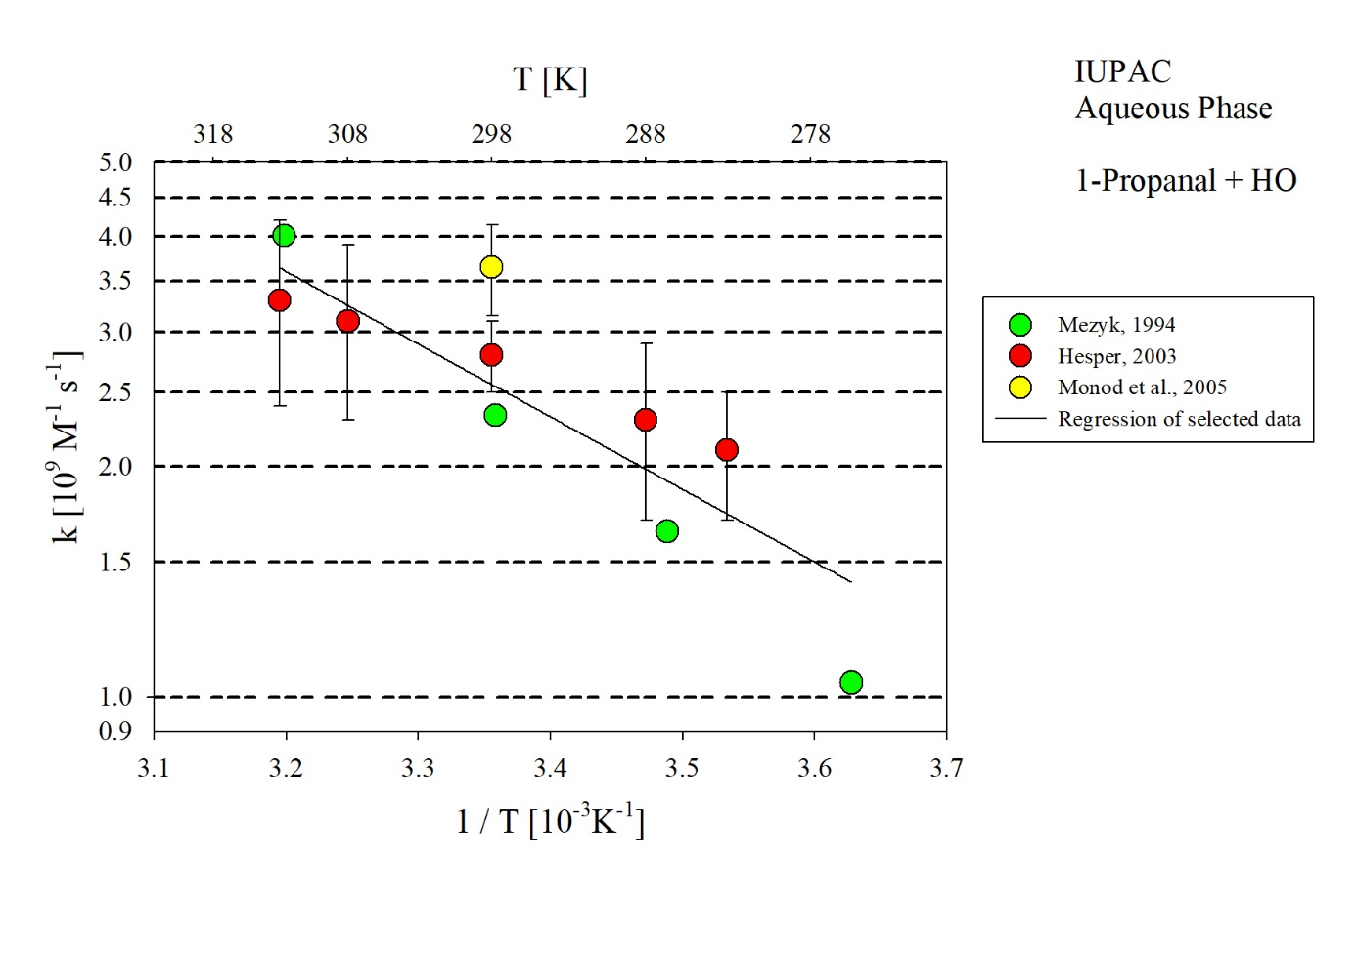
T-dependent rate coefficients for the reaction of 1-propanal with HO in aqueous solution. Data from Mezyk (1994) and Hesper (2003) have been used for regression.

