IUPAC Task Group on Atmospheric Chemical Kinetic Data Evaluation
– Data Sheet AQ_OH_5
Datasheets can be downloaded for personal use only and must not be retransmitted or disseminated either electronically or in hardcopy without explicit written permission.
The citation for this datasheet is: IUPAC Task Group on Atmospheric Chemical Kinetic Data Evaluation, http://iupac.pole-ether.fr.
This datasheet last evaluated: June 2019; last change in preferred values: March 2019
HO (aq) + CH₃(CH₂)₃OH (aq) | → | CH₃CH₂CH₂CHOH (aq) (41%)
 |  | + CH₂CH₂CH₂CH₂OH (aq)
+ CH₃CHCH₂CH₂OH (aq)
+ CH₃CH₂CHCH₂OH (aq) (58.5%)
+ H₂O (l)

(Product distributions taken from Buxton et al., 1988, originally determined by Asmus et al., 1973 via PR - UV/Vis)

Rate coefficient data

k/ l mol⁻¹ s⁻¹ | T/K | pH |  | I/ mol l⁻¹ | Reference |  |  | Technique/ Comments
Absolute Rate Coefficients
(4.1 ±0.8) × 10⁹ | 298 | 5.8 | - |  |  | Hesper, 2003 Herrmann, 2003 | LP/LPA (a1)
1.0 × 10¹¹ exp[-(1000 ± 100)K/T] | 288 - 328 | 5.8 | - |  |  |  | LP/LPA (a2)
Relative Rate Coefficients
3.73 × 10⁹ | 294 | 7 | - |  |  | Adams et al.  1965 | PR / UV-vis (b)
4.2 × 10⁹ | 294 | 7 | - |  |  | Adams et al.,  1965 | PR / UV-vis (c)
3.8 × 10⁹ | 294 | 9 | - |  |  | Anbar et al.,  1966 | CW-radiolysis / UV-vis (d)
4.6 × 10⁹ | 294 | 2 | - |  |  | Scholes and Willson, 1967 | CW-radiolysis / UV-vis (e)
4.6 × 10⁹ | 294 | 5 | - |  |  |  | CW-radiolysis / UV-vis (e1)
4.4 × 10⁹ | 294 | - | 2 × 10⁻² |  |  | Willson et al.,  1971 | CW-radiolysis / UV-vis (f)
(5.1 ±0.4) × 10⁹ | 291-298 | 6.9 | - |  |  | Prütz and Vogel, 1976 | CW-radiolysis / UV-vis (g)
(4.2 ±0.4) × 10⁹ | 298 | 1-2 | - |  |  | Monod et al.,  2005 | ASC /  GC-FID (h)

ΔG_{R}° (aq): Aqueous phase thermochemical data not available. As well, gas phase thermochemical data Η_{R}° (g) are not available.

Comments

- Product formation observed at 260 nm; direct observation of optical absorption of the peroxyl-radicals formed by the reaction between HO, 1-Butanol and O₂; oxygen saturated solutions (a1): determination of the temperature influence; the Arrhenius expression (a2) was calculated using these values

- Product formation observed at 500 nm; Reference reaction: HO + SCN⁻; k(HO + SCN⁻) = 6.6 × 10⁹ M⁻¹s⁻¹; the rate coefficient has been recalculated using the selected rate coefficient for the reference reaction (1.10 × 10¹⁰ M⁻¹s⁻¹; Zhu et al., 2003); No exact value is given for the initial concentrations of the reactants (‘a few millimolar’); air or oxygen saturated solutions; as no exact temperature is given, for room temperature T = 294 K is assumed.

- Product formation observed at 500 nm; reference system: HO + CO₃²⁻ with k(HO + CO₃²⁻) = 2.0 × 10⁸ M⁻¹s⁻¹; the rate coefficient has been recalculated using the selected rate coefficient for the reference reaction (3.77 × 10⁸ M⁻¹s⁻¹); no values given for the initial concentrations of the reactants; oxygen saturated solutions; as no exact temperature is given, for room temperature T = 294 K is assumed.

- Reference reaction: HO + PNDA (p-nitrosodimethylaniline); rate coefficients of the reference reactions were determined versus ethanol with k(HO + ethanol) = 1.10 × 10⁹ M⁻¹s⁻¹; recalculation was performed using the selected rate coefficient (1.88 × 10⁹ M⁻¹s⁻¹); no values given for the initial concentrations of the reactants; air saturated solutions; all experiments were repeated at least four times and the coefficient of variation was less than ± 10%; as no exact temperature is given, for room temperature T = 294 K is assumed.

- Product formation observed at 264 nm; Reference reaction: HO + thymine; k(HO + thymine) = (4.3 ±1) × 10⁹ M⁻¹s⁻¹; rate coefficient was recalculated using the selected value for the reference reaction (5.38 × 10⁹ M⁻¹s⁻¹); c(thymine) = 8 × 10⁻⁵ - 2 × 10⁻⁴ mol/l; The rate coefficient of the reference reaction was determined relative to benzene ; aerated solutions; The absolute rate coefficients have an error of about ±25%; as no exact temperature is given, for room temperature T = 294 K is assumed.
Note: the reference values listed in table 1 were normalized to k(HO + ethanol) = 1.85 × 10⁹ M⁻¹s⁻¹

- Product formation observed at 410 nm; Reference reaction: HO + [Fe(CN)₆]⁴⁻ with k(HO + [Fe(CN)₆]⁴⁻) = (0.93 ±0.05) × 10¹⁰ M⁻¹s⁻¹; rate coefficients have been recalculated using the selected rate coefficient for reference reactions (1.03 × 10¹⁰ M⁻¹s⁻¹); c([Fe(CN)₆]⁴⁻) = 2 × 10⁻³ mol/l; in most reactions air was present or the solutions were saturated with N₂O; as no exact temperature is given, for room temperature T = 294 K is assumed.

- Products analysed by fluorescence measurements using Acriflavin as RCL (Radiation Induced Chemiluminescence)-dye; The absolute rate coefficients were obtained by comparing the slopes of the emission yields plotted against the concentrations of the different scavengers and using k(HO + methanol) = 8.5 × 10⁸ M⁻¹s⁻¹ as reference; rate coefficient was recalculated using the selected value for the reference reaction (9.22 × 10⁸ M⁻¹s⁻¹).

- Radicals generated by Photo-Fenton-reaction in a bulk reactor (an ‘aqueous phase smog chamber’ or ‘ASC’), products analysed by GC-FID; Reference reactions: HO + 1-propanol; k(HO + 1-propanol) = 2.8 × 10⁹ M⁻¹s⁻¹ and HO + 2-propanol; k(HO + 2-propanol) = 1.9 × 10⁹ M⁻¹s⁻¹ with no values given for the rate coefficients of the individual determinations.

Preferred Values

Parameter | Value | T/K
k / l mol⁻¹ s⁻¹ | 4.30 × 10⁹ | 298
k / l mol⁻¹ s⁻¹ | 5.16 × 10¹⁰ exp[-(750)/T] | 288 - 328

Reliability
Δ log k | ± 0.04 | 298
Δ E_{A}/R | ± 220 | 288 – 328

Comments on Preferred Values

A rate coefficient of k = 4.2 × 10⁹ l mol⁻¹ s⁻¹ was recommended by Buxton et al. in 1988. To obtain the overall recommended T-dependent data, all available rate coefficients were used for regression. The obtained room temperature rate coefficient is slightly higher, then suggested, but can be explained well by the recalculated data of the determinations. The rate coefficient determined by Monod et al. (2005) is published as the mean of two determinations without stating the values of the single determinations. Therefore, a further evaluation of this rate coefficient cannot be undertaken, but it has to stated, that the recommended mean value of their work agrees well within error limits.
The uncertainty for the recommended rate coefficient is estimated and determined to be Δ log k = ±0.04 or ±10%.

References

Adams, G. E., Boag, J. W., and Michael, B. D.: Trans. Faraday Soc., 61, 1417-1424, 1965.

Adams, G. E., Boag, J.W., Currant, J. and Michael, B.D., Pulse Radiolysis, Ebert, M., Keene, J.P., Swallow, A.J. and Baxendale, J.H. (eds.): Academic Press, New York, 131-143, 1965.

Anbar, M., Meyerstein, D., and Neta, P.: J. Chem. Soc. B, 742-747, 1966.

Asmus, K. D., Möckel, H. and Henglein, A.: J. Phys. Chem., 77(10), 1218-1221, 1973.

Buxton, G. V., Greenstock, C. L., Helman, W. P., and Ross, A. B.: J. Phys. Chem Ref. Data, 17(2), 513-886, 1988.

Herrmann, H.: Chem. Rev., 103(12), 4691-4716, 2003.

Hesper, J.: Ph.D. Dissertation, University of Leipzig, Leipzig, Germany, 2003.

Monod, A., Poulain, L., Grubert, S., Voisin, D., and Wortham, H.: Atmos. Environ., 39(40), 7667-7688, 2005.

Pruetz, W. A. and Vogel, S.: Z. Naturforsch., B: Chem. Sci., 31(11), 1501-1510, 1976.

Scholes, G., and Willson, R. L.: Trans. Faraday Soc., 63, 2983-2993, 1967.

Willson, R. L., Greenstock, C. L., Adams, G. E., Wageman, R., and Dorfman, L. M.: Int. J. Radiat. Phys. Chem., 3(3), 211-220, 1971.

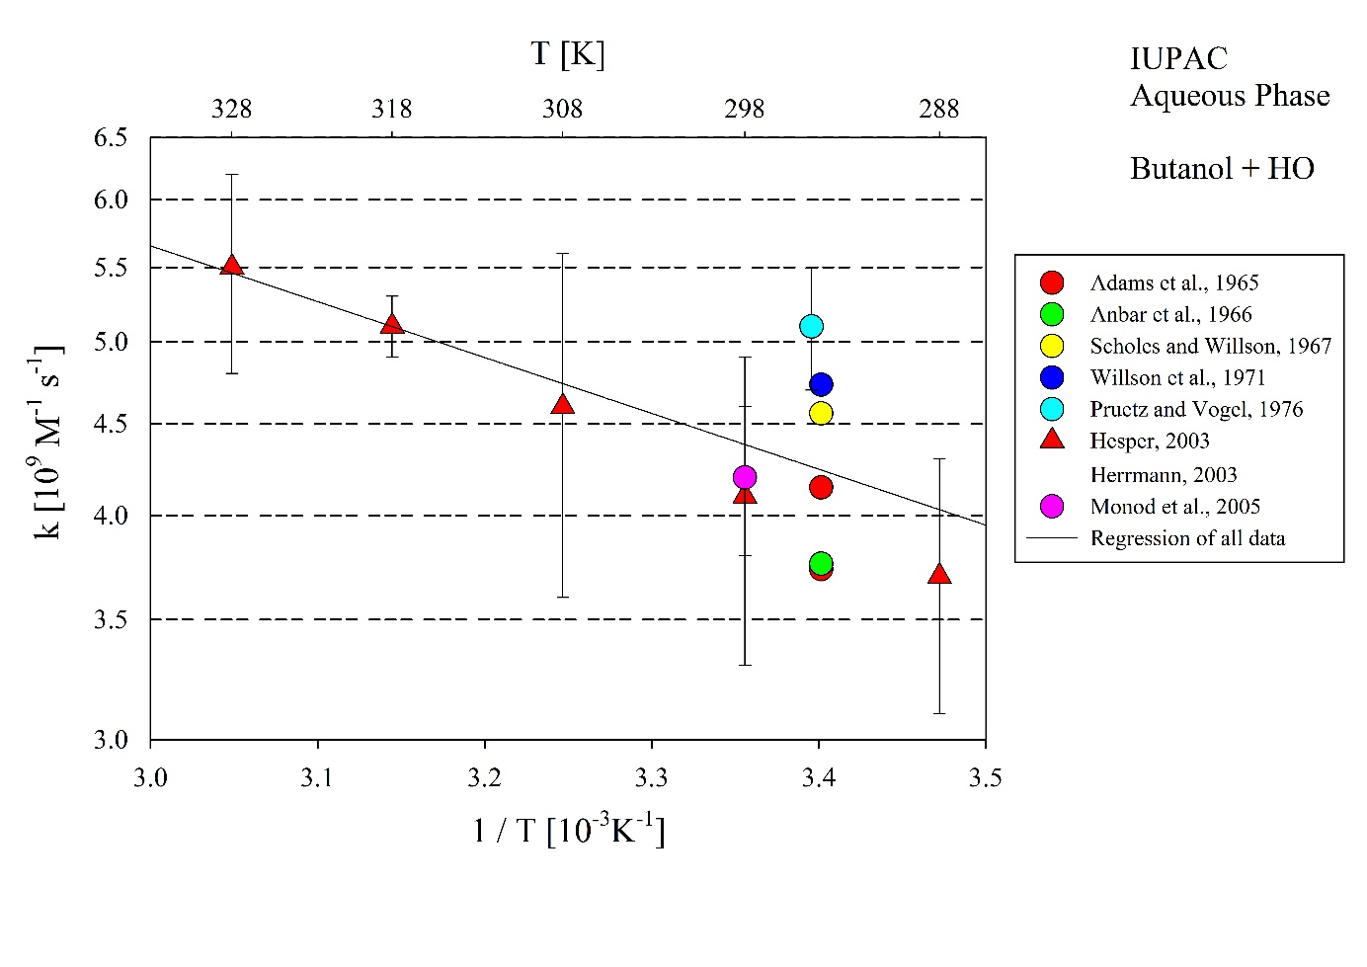
T-dependent rate coefficients for the reaction of 1-Butanol with HO in aqueous solution. The rate coefficient by Monod et al. (2005) is excluded from the regression.

