IUPAC Task Group on Atmospheric Chemical Kinetic Data Evaluation
– Data Sheet AQ_OH_4
Datasheets can be downloaded for personal use only and must not be retransmitted or disseminated either electronically or in hardcopy without explicit written permission.
The citation for this datasheet is: IUPAC Task Group on Atmospheric Chemical Kinetic Data Evaluation, http://iupac.pole-ether.fr.
This datasheet last evaluated: June 2019; last change in preferred values: March 2019
HO(aq) + CH₃CHOHCH₃ (aq) | → | CH₃COHCH₃ (aq) (85.5%)
 |  | + CH₃CHOCH₃ (aq) (1.2%)
+ CH₂CHOHCH₃ (aq) (13.3%)
+ H₂O (l)

(Product distributions taken from Buxton et al., 1988, originally determined by Asmus et al., 1973 via PR - UV/Vis)

Rate coefficient data

k/ l mol⁻¹ s⁻¹ | T/K |  | pH |  | I/ mol l⁻¹ |  | Reference |  | Technique/ Comments
Absolute Rate Coefficients
2.0 × 10⁹ |  | - | slightly <pH 7 | - |  | Janata, 2002 |  | PR/UV-vis abs. (a)
2.0 × 10⁹ |  | - | slightly <pH 7 | - |  | Alam et al., 2003 |  | PR/UV-vis abs. (b)
(2.1 ± 0.2) × 10⁹  (2.8 ± 0.7) × 10⁹  (3.6 ± 0.4) × 10⁹  (4.1 ± 0.4) × 10⁹  (4.6 ± 0.6) × 10⁹  (4.2 ± 1.4) × 10⁹  (4.6 ± 3.3) × 10⁹ |  | 298 | 5.8 | 0  0.5 (0.46)  1.0 (0.85)  1.5 (1.21)  2.0 (1.53)  2.5 (1.83)  3.0 (2.11) |  | Hesper, 2003 |  | LP/LPA (c1)
6.1 × 10¹⁰ exp[-(1000 ± 300)K/T] |  | 288-328 | - | - |  |  |  | LP/LPA (c2)
Relative Rate Coefficients
2.13 × 10⁹ |  | 295-298 | 9 | - |  | Kraljic et al., 1965 |  | CW-radiolysis /UV-vis abs. (d)
6.5 × 10⁹ |  | 294 | 7 | - |  | Adams et al., 1965 |  | PR/UV-vis abs. (e)
1.6 × 10⁹ |  | 294 | - | 1.0 |  | Heckel et al., 1965 |  | PR/UV-vis abs. (f)
(2.08 ± 0.2) × 10⁹ |  | 294 | 2.0-2.2 | - |  | Scholes et al., 1965 |  | CW-radiolysis /UV-vis abs. (g)
1.86 × 10⁹ |  | 294 | 7 | - |  | Thomas, 1965 |  | PR/UV-vis abs. (h)
3.04 × 10⁹ |  | 293 | 7 | - |  | Woodward and Sutton, 1966 |  | CW-radiolysis (i)
2.22 × 10⁹ |  | 294 | 6 | - |  | Anbar et al., 1966 |  | CW-radiolysis /UV-vis abs. (j₁)
2.05 × 10⁹ |  | 294 | 9 | - |  |  |  | CW-radiolysis /UV-vis abs. (j₂)
2.25 × 10⁹ |  | 294 | 2 | - |  | Scholes and Willson, 1967 |  | CW-radiolysis /UV-vis abs. (k1)
2.25 × 10⁹ |  | 294 | 5 | - |  |  |  | (k2)
1.83 × 10⁹ |  | 294 | - | - |  | Greenstock et al., 1968 |  | PR/UV-vis abs. (l)
1.5 × 10⁹ |  | 294 | 7 | - |  | Baxendale and Khan, 1969 |  | PR/UV-vis abs. (m)
2.22 × 10⁹ |  | 294 | - | - |  | Willson et al., 1971 |  | CW-radiolysis /UV-vis abs.(n)
(2.08 ± 0.14) × 10⁹ |  | 291-298 | 6.9 | - |  | Prütz et al., 1976 |  | CW-radiolysis / fluorescence detection (o1)
(2.6 ± 0.3) × 10⁹ |  | 291-298 | 7 | - |  |  |  | CW-radiolysis / fluorescence detection (o2)
1.8 × 10⁹ |  | 291-298 | 10.4 | - |  |  |  | CW-radiolysis / fluorescence detection (o3)
(2.0 ± 0.1) × 10⁹ |  | 294 | 6 | 0.3 × 10⁻³ |  | Wolfenden and Willson, 1982 |  | PR/UV-vis abs. (p)
2.2 × 10⁹ |  | 292 | - | 2-10 × 10⁻³ |  | Elliot and Simsons, 1984 |  | PR/UV-vis abs. (q1)
7.41 × 10¹⁰ exp[-(1000±70)/T] |  | 292 - 352 | - | - |  |  |  | (q2)
1.6 × 10⁹ |  | 294 | 7.5 | - |  | Motohashi and Saito, 1993 |  | CW-irradiation /HPLC (r)
(2.2 ± 0.2) × 10⁹ |  | 298 | 1-2 | - |  | Monod et al., 2005 |  | ASC/  GC-FID (s)

ΔG_{R}° (aq): Aqueous phase thermochemical data not available
For comparison: ΔΗ_{R}° (g) = -58.8 kJ·mol⁻¹ (gas phase data sheet HOx_VOC26)

Comments

- Direct observation of the alcohol radicals (260-290 nm); computer simulations were used to derive the rate coefficients; the simulations were accurate to 5%; N₂O saturated solutions.

- Essentially the same article as (a)

- Product formation observed at 248 nm; direct observation of optical absorption of the peroxyl-radicals formed by the reaction between HO, 2-propanol and O₂; oxygen saturated solutions (c1): determination of ion strength influence; NaClO₄ was used to adjust the ion strength; the numbers given in parenthesis refer to the calculated effective ion strength; (c2): determination of the temperature influence from 288-328 K; the Arrhenius expression was calculated using these values.

- Product formation observed at (440 nm); Reference reaction: HO + PNDA (p-nitrosodimethylaniline); rate coefficient of the reference reaction was estimated to ~1 × 10¹⁰ M⁻¹s⁻¹; the relative rate coefficient was determined to be 17.0 (relative to k(HO + PNDA = 100)) ; the relative rate coefficient has an error of about ± 5%

- Product formation observed at 500 nm; reference reaction: HO + SCN⁻ with k(HO + SCN⁻) = 6.6 × 10⁹ M⁻¹s⁻¹; the rate coefficient was recalculated using the selected rate coefficient for the reference reaction (1.08 × 10¹⁰ M⁻¹s⁻¹; Zhu et al., 2003); No exact value is given for the initial concentrations of the reactants (‘a few millimolar’) ; air or oxygen saturated solutions; as no exact temperature is given, for room temperature T = 294 K is assumed.

- Reference reaction: HO + HSO₄⁻ ; k(HO + HSO₄⁻) = 8.0 × 10⁵ M⁻¹s⁻¹ was taken from Adams et al. (1965) ; the absolute rate coefficient for the reaction HO + i-propanol was calculated from the relative value (k = 3.6) listed in Table 1 of the reference, which was normalized to the methanol reaction (k(·OH + methanol) = 4.4 × 10⁸ M⁻¹s⁻¹); as no exact temperature is given, for room temperature T = 294 K is assumed.

- Product formation observed at 264 nm; reference reaction: HO + thymine with k(HO + thymine) = 3.1 × 10⁹ M⁻¹s⁻¹; rate coefficient was recalculated using the selected rate coefficient for reference reactions (5.38 × 10⁹ M⁻¹s⁻¹); c(thymine) = 8 - 20 × 10⁻⁵ mol/l; air or oxygen saturated solutions; as no exact temperature is given, for room temperature T = 294 K is assumed.

- Product formation observed at 400 nm; reference reaction: HO + I⁻; k(HO + I⁻) = (1.02 ±0.13) × 10¹⁰ M⁻¹s⁻¹; rate coefficient was recalculated using the selected rate coefficient for reference reactions (1.09 × 10¹⁰ M⁻¹s⁻¹); no values given for concentrations; as no exact temperature is given, for room temperature T = 294 K is assumed.

- Product yields determined by UV-vis abs., chromatography and other methods not described in the article; Reference reaction: HO + NO; k(HO + NO) = 6.0 × 10⁹ M⁻¹s⁻¹; a relative rate coefficient of k_{(HO + NO)} / k_{(HO + iPrOH)} is given as (4.8 ±0.6); determined rate coefficients were than referenced to k_{(HO + EtOH)}, defined as 1; recalculation of was performed using the selected value for the reference rate coefficient k(HO + NO) = 1.46 × 10⁹ M⁻¹s⁻¹.

- Reference reactions: HO + Br⁻ (j1); HO + PNDA (p-nitrosodimethylaniline) (j2); no values given for initial concentrations; rate coefficients of the reference reactions were determined versus ethanol with k(HO + ethanol) = 1.88 × 10⁹ M⁻¹s⁻¹; air saturated solutions; all experiments were repeated at least four times and the coefficient of variation was less than ± 10%; as no exact temperature is given, for room temperature T = 294 K is assumed.

- Product formation observed at 264 nm; reference reaction: HO + thymine with k(HO + thymine) = 4.3 ± 1 × 10⁹ M⁻¹s⁻¹; rate coefficient was recalculated using the selected rate coefficient for the reference reaction (5.38 × 10⁹ M⁻¹s⁻¹); c(thymine) = 8 × 10⁻⁵ - 2 × 10⁻⁴ mol/l ; rate coefficient of reference reaction determined relative to benzene; aerated solutions ; absolute rate coefficients given have an error of about ± 25%; as no exact temperature is given, for room temperature T = 294 K is assumed.

- Product formation observed at 500 nm; reference reaction: HO + SCN⁻ with k(HO + SCN⁻) = (7.5 ±0.5) × 10⁹ M⁻¹s⁻¹; c(KSCN) = 2 × 10⁻³ mol/l; aerated solutions; recalculation was performed using the selected rate coefficient for the reference reaction (1.10 × 10⁹ M⁻¹s⁻¹) as no exact temperature is given, for room temperature T = 294 K is assumed.

- Product formation observed at 440 nm; reference reaction: HO + PNDA (p-nitrosodimethylaniline); k(HO +PNDA) = 1.25 × 10¹⁰ M⁻¹s⁻¹; no values given for concentrations; aerated solutions

- Product formation observed at 410 nm; reference reaction: HO + [Fe(CN)₆]⁴⁻ with k(HO + [Fe(CN)₆]⁴⁻) = (0.93 ±0.05) × 10¹⁰ M⁻¹s⁻¹; rate coefficient has been recalculated using the selected value for the reference reaction (1.03 × 10¹⁰ M⁻¹s⁻¹) c([Fe(CN)₆]⁴⁻) = 2 × 10⁻³ mol/l ; in most reactions air was present or the solutions were saturated with N₂O; as no exact temperature is given, for room temperature T = 294 K is assumed.

- Products analysed by fluorescence measurements using acriflavin ((o1) and (o2)) and Fluorescein (o3) as RCL (Radiation Induced Chemiluminescence)-dye; The absolute rate coefficients were obtained by comparing the slopes of the emission yields plotted against the concentrations of the different scavengers and using k(HO + methanol) = 8.5 × 10⁸ M⁻¹s⁻¹ as reference; recalculation was performed using the selected value for the rate coefficient of the reference reaction (9.22 × 10¹⁰ M⁻¹s⁻¹).

- Product formation observed at 415 nm; reference reaction: HO + ABTS (2,2’-Azinobis-(3-ethylbenzthiazoline-6-sulphonate)); k(HO + ABTS) = 1.2 × 10¹⁰ M⁻¹s⁻¹, c(ABTS) = 1 × 10⁻⁴ mol/l; N₂ and N₂O saturated solutions; as no exact temperature is given, for room temperature T = 294 K is assumed.

- Product formation observed at 420 nm; reference reaction: HO + SCN⁻; relative rate coefficients given as k_{S}/k_{R}; c(KSCN) in the range of 2-10 × 10⁻³ mol/l; N₂O saturated solutions. Arrhenius expression (q2) calculated using the relative data k_{S}/k_{R} from table 1, relative to the selected T-dependent rate coefficients (Zhu et al., 2003) considering 10% error of activation energy.

- Products analysed by HPLC (abs. 240-300 nm) and fluorescence measurements (irradiation at 305 nm); Reference reaction: HO + benzoate ; k(HO + benzoate) = 5.9 × 10⁹ M⁻¹s⁻¹; c(benzoate) = 2 × 10⁻⁴ mol/l; deviations of less than ±5% for the determined rate coefficients; N₂O saturated solutions; as no exact temperature is given, for room temperature T = 294 K is assumed.

- Radicals generated by Photo-Fenton-reaction in a bulk reactor (an ‘aqueous phase smog chamber’ or ‘ASC’), products analysed by GC-FID; Reference reaction: HO + 1-propanol with k(HO + 1-propanol) = 2.8 × 10⁹ M⁻¹s⁻¹; recalculation performed using the selected value for the reference reaction (3.18 × 10⁹ M⁻¹s⁻¹).

Preferred Values

Parameter | Value | T/K
k / l mol⁻¹ s⁻¹ | 2.27 × 10⁹ | 298
k / l mol⁻¹ s⁻¹ | 1.17 × 10¹¹ exp[-(1180 / T)] | 288 - 352

Reliability
Δ log k | ± 0.15
Δ E_{A}/R | ± 200

Comments on Preferred Values

Buxton et al. (1988) recommended a rate coefficient of 1.9 × 10⁹ M⁻¹s⁻¹. Considering the only temperature dependent kinetic data from Elliot and Simsons (1984) as well as the remaining averaged data available, a slightly higher rate coefficient is suggested. The latest determination by Monod (2005) also agrees with the preferred value. Data determined by Adams et al. (1965) and Heckel et al. (1965) have not been considered for the evaluation. For the method of Heckel et al. it must be considered that the rate coefficient is exceeding its reference rate constant by a factor of 10³ requiring very high reference reactant concentrations and leading to high uncertainties. The error of the recommended room temperature rate coefficient is estimated to be Δ log k = ±0.15 or ±33%.

References

Adams, G.E., Boag, J.W., Currant, J. and Michael, B.D., Pulse Radiolysis, Ebert, M., Keene, J.P., Swallow, A.J. and Baxendale, J.H. (eds.): Academic Press, New York, 131-143, 1965.

Alam, M. S., Rao, B. S. M. and Janata, E.: Radiat. Phys. Chem., 67(6), 723-728, 2003.

Anbar, M., Meyerstein, D. and Neta, P.: J. Chem. Soc. B, 742-747, 1966.

Asmus, K. D., Möckel, H. and Henglein, A.: J. Phys. Chem., 77(10), 1218-1221, 1973.

Baxendale, J. H. and Khan, A. A.: Int. J. Radiat. Phys. Chem., 1(1), 11-24, 1969.

Buxton, G. V., Greenstock, C. L., Helman, W. P. and Ross, A. B.: J. Phys. Chem Ref. Data, 17(2), 513-886, 1988.

Elliot, A. J. and Simsons, A. S.: Radiat. Phys. Chem., 24(2), 229-231, 1984.

Greenstock, C. L., Ng, M. and Hunt, J.: Radiat. Chem. I. Adv. in Chem. Ser, 81, 397-417, 1968.

Heckel, E., Henglein, A. and Beck, G.: Ber. Bunsenges. Phys. Chem., 70(2), 149-154, 1966.

Hesper, J.: Ph.D. Dissertation, University of Leipzig, Leipzig, Germany, 2003.

Janata, E.: J. Chem. Sci., 114(6), 731-737, 2002.

Kraljić, I. and Trumbore, C. N.: J Am. Chem. Soc., 87(12), 2547-2550, 1965.

Monod, A., Poulain, L., Grubert, S., Voisin, D. and Wortham, H.: Atmos. Environ., 39(40), 7667-7688, 2005.

Motohashi, N. and Saito, Y.: Chem. Pharm Bull., 41(10), 1842-1845, 1993.

Pruetz, W. A. and Vogel, S.: Z. Naturforsch., B: Chem. Sci., 31(11), 1501-1510, 1976.

Scholes, G. and Willson, R. L.: Trans. Faraday Soc., 63, 2983-2993, 1967.

Scholes, G., Shaw, P. and Willson, R.L.: Pulse Radiolysis, academic press, 61, 1965

Thomas, J. K.: Trans. Faraday Soc., 61, 702-707, 1965.

Willson, R. L., Greenstock, C. L., Adams, G. E., Wageman, R. and Dorfman, L. M.: Int. J. Radiat. Phys. Chem., 3(3), 211-220, 1971.

Wolfenden, B. S. and Willson, R. L.: J. Chem. Soc. Perkin Trans. II, 7, 805-812, 1982.

Woodward, T. W. and Sutton, H. C.: Trans. Faraday Soc., 62, 70-80, 1966.

Zhu, L., Nicovich, J. M. and Wine, P. H.: Aquat. Sci., 65(4), 425-435, 2003.

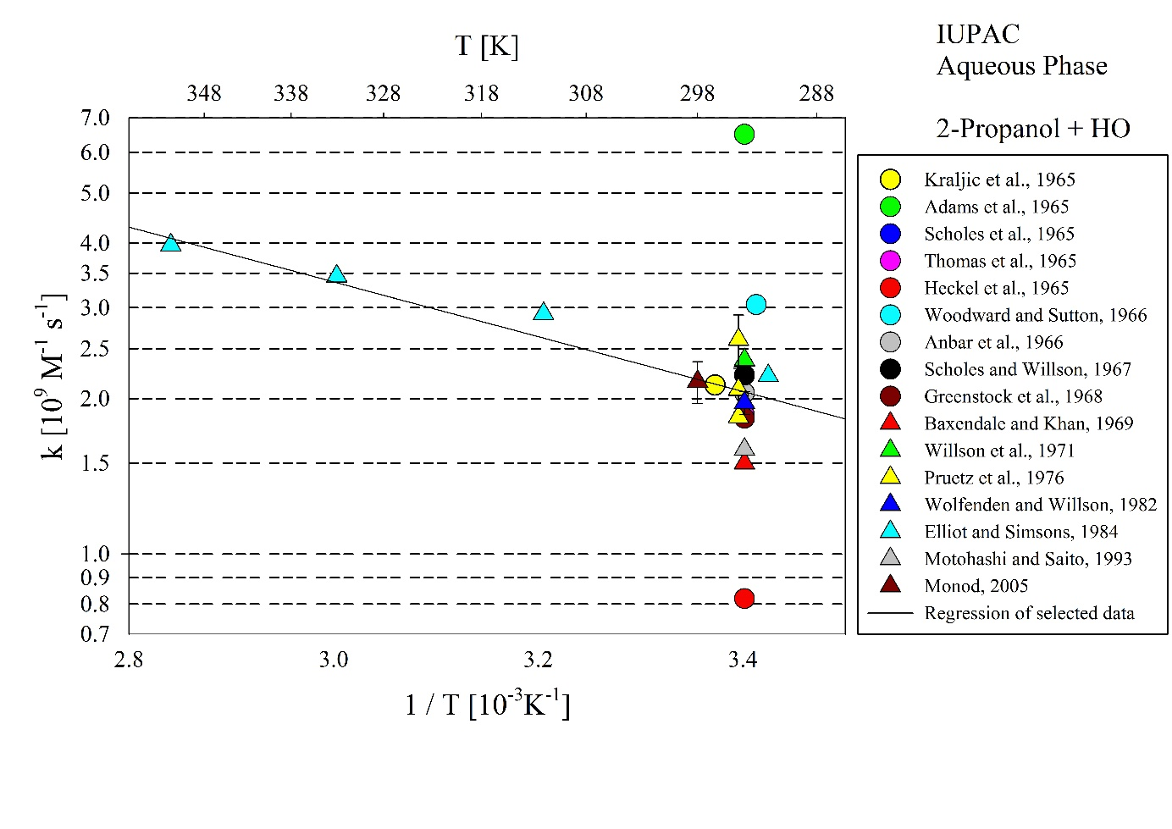
T-dependent rate coefficients for the reaction of 2-Propanol with OH in aqueous solution. Rate coefficients determined by Adams et al. (1965) and Heckel et al. (1966) were excluded from the regression.

