IUPAC Task Group on Atmospheric Chemical Kinetic Data Evaluation
– Data Sheet AQ_OH_45
Datasheets can be downloaded for personal use only and must not be retransmitted or disseminated either electronically or in hardcopy without explicit written permission.
The citation for this datasheet is: IUPAC Task Group on Atmospheric Chemical Kinetic Data Evaluation, http://iupac.pole-ether.fr.
This datasheet last evaluated: June 2019; last change in preferred values: June 2019

HO(aq) + CH₃CH₂CHOHCH₂OH(aq) → products

Rate coefficient data

k/ L mol⁻¹ s⁻¹ | T/K | pH | I/ mol L⁻¹ | Reference | Technique/ Comments
Relative Rate Coefficients
(2.2 ± 0.4) × 10⁹ | 298 | 7 | - | Hoffmann et al., 2009 | LFP-LPA (a)
2.36 × 10¹¹ exp[-(1400 ± 250)/T] | 288 - 328 | 7 | - |  | LFP-LPA (a1)

ΔG_{R}° (aq): Aqueous phase thermochemical data not available. As well, gas phase thermochemical data Η_{R}° (g) are not available.

Comments

(a) Radicals generated by laser flash photolysis (LFP) of H₂O₂ (c(H₂O₂) = 1 × 10⁻⁴ M) at 248 nm; rate constant was determined to be k = 2.3 × 10⁹ M⁻¹s⁻¹, referring to reference reaction: HO + SCN⁻ with k(HO + SCN⁻) = 1.24 × 10¹⁰ M⁻¹ s⁻¹; the selected temperature dependence by Zhu et al. (2003) was used for recalculation; c(KSCN) = 1.59 × 10⁻⁵ M. Arrhenius expression (a1) was calculated using the recalculated experimental data from Hoffmann et al. (2009).

Preferred Values

Parameter | Value | T/K
k / L mol⁻¹ s⁻¹ | 2.2 × 10⁹ | 298
k / L mol⁻¹ s⁻¹ | 2.36 × 10¹¹ exp[-(1400)/T] | 288 – 328

Reliability
Δ log k | ±0.15 | 298
Δ E_{A}/R | ±250 | 288 – 328

Comments on Preferred Values

The rate constants determined by Hoffmann et al. (2009) are the only ones available for the reaction of butan-1,2-diol. They have been recalculated using the recommended rate constants for the reference reaction (Zhu et al., 2003). The uncertainty is estimated to be ±20 % or Δ log k = ±0.15.

References

Hoffmann, D., Weigert, B., Barzaghi, P. and Herrmann, H.: Phys. Chem. Chem. Phys., 11, 9351-9363, 2009.

Zhu, L., Nicovich, J. M. and Wine, P. H.: Aquat. Sci., 65(4), 425-435, 2003.

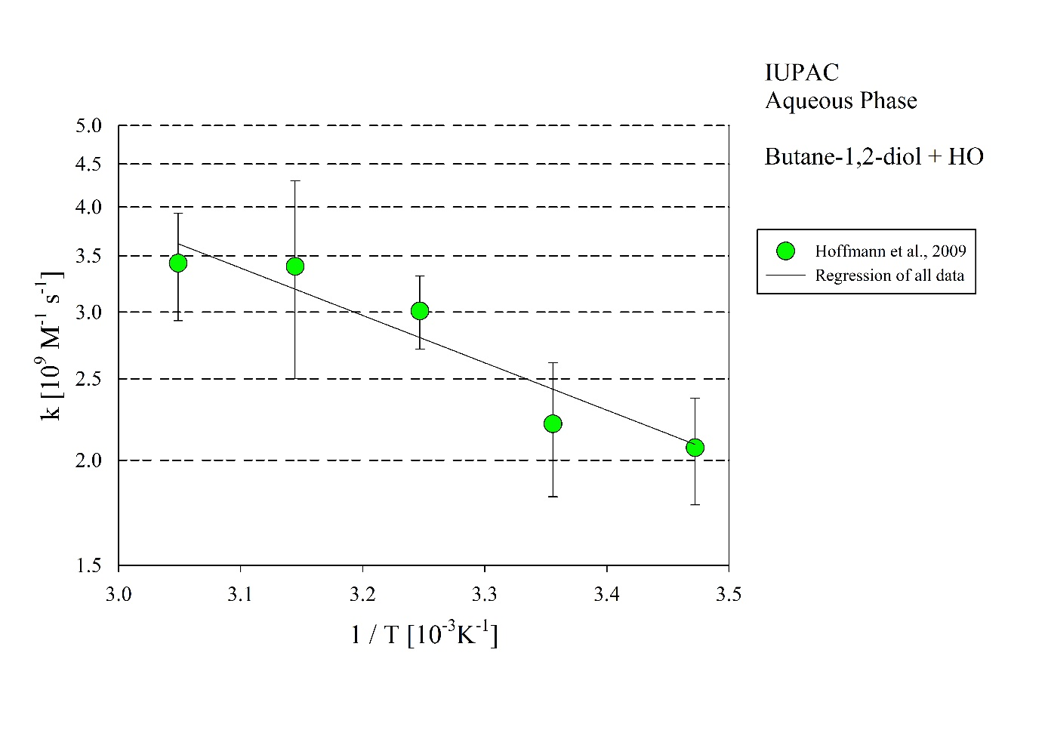T-dependent rate constants for the reaction of butane-1,2-diol with HO in aqueous solution. Data from Hoffmann et al. (2009).

