IUPAC Task Group on Atmospheric Chemical Kinetic Data Evaluation
– Data Sheet AQ_OH_43
Datasheets can be downloaded for personal use only and must not be retransmitted or disseminated either electronically or in hardcopy without explicit written permission.
The citation for this datasheet is: IUPAC Task Group on Atmospheric Chemical Kinetic Data Evaluation, http://iupac.pole-ether.fr.
This datasheet last evaluated: June 2019; last change in preferred values: June 2019

HO(aq) + HO(CH₂)₄OH(aq) → products

Rate coefficient data

k/ L mol⁻¹ s⁻¹ | T/K | pH | I/ mol L⁻¹ | Reference | Technique/ Comments
Relative Rate Coefficients
3.23 × 10⁹ | 294 | - | - | Adams et al., 1965 | PR / UV-Vis(a)
(3.4 ± 0.1) × 10⁹ | 298 | 7 | - | Hoffmann et al., 2009 | LFP-LPA (b)
9.7 × 10¹⁰ exp[-(1000 ± 80)/T] | 288 - 328 | 7 | - |  | LFP-LPA (b1)

ΔG_{R}° (aq): Aqueous phase thermochemical data not available. As well, gas phase thermochemical data Η_{R}° (g) are not available.

Comments

(a) Reference reaction: HO + SCN⁻ with k(HO + SCN⁻) = 6.6 × 10⁹ M⁻¹s⁻¹; the selected reference rate coefficient k = 1.10 × 10¹⁰ M⁻¹s⁻¹ was used for recalculation; No exact value is given for the initial concentrations of the reactants; pH is given as natural; as no exact temperature is given, T = 294 K is assumed for room temperature.

(b) Radicals generated by laser flash photolysis (LFP) of H₂O₂ (c(H₂O₂) = 1 × 10⁻⁴ M) at 248 nm; reference reaction: HO + SCN⁻ with k(HO + SCN⁻) = 1.24 × 10¹⁰ M⁻¹ s⁻¹; the selected reference rate constant k = 1.19 × 10¹⁰ M⁻¹s⁻¹ was used for recalculation; c(KSCN) = 1.59 × 10⁻⁵ M. Arrhenius expression (b1) was calculated using the recalculated experimental data from Hoffmann et al. (2009), based on the recommended Arrhenius expression k(T) = 3.45209 × 10¹² × exp(-14050 / RT) (Zhu et al., 2003).

Preferred Values

Parameter | Value | T/K
k / L mol⁻¹ s⁻¹ | 3.33 × 10⁹ | 298
k / L mol⁻¹ s⁻¹ | 9.04 × 10¹⁰ exp[-(1000)/T] | 288 – 328

Reliability
Δ log k | ±0.09 | 298
Δ E_{A}/R | ±70 | 288 – 328

Comments on Preferred Values

For the recommended rate constant, data determined by Adams et al. (1965) and Hoffmann et al. (2009) have been used for regression. The available data agree well with each other as well as with the former recommendation by Buxton et al. of 1988 when the latter is recalculated to 3.2 × 10¹⁰ M⁻¹ s⁻¹. The uncertainty is estimated as ±20% or Δ log k = ±0.09.

References

Adams, G. E., Boag, J. W. and Michael, B. D.: Trans. Faraday Soc., 61, 1417-1424, 1965.

Buxton, G. V., Greenstock, C. L., Helman, W. P. and Ross, A. B.: J. Phys. Chem. Ref. Data, 12(2), 513 – 886, 1988.

Chin, M., and Wine, P. H: J. Photochem. Photobiol., A, 69(1), 17-25, 1992.

Hoffmann, D., Weigert, B., Barzaghi, P. and Herrmann, H.: Phys. Chem. Chem. Phys., 11, 9351-9363, 2009.

Monod, A. and Doussin, J. F.: Atmos. Environ., 42, 7611–7622, 2008.

Zhu, L., Nicovich, J. M. and Wine, P. H.: Aquat. Sci., 65(4), 425-435, 2003.

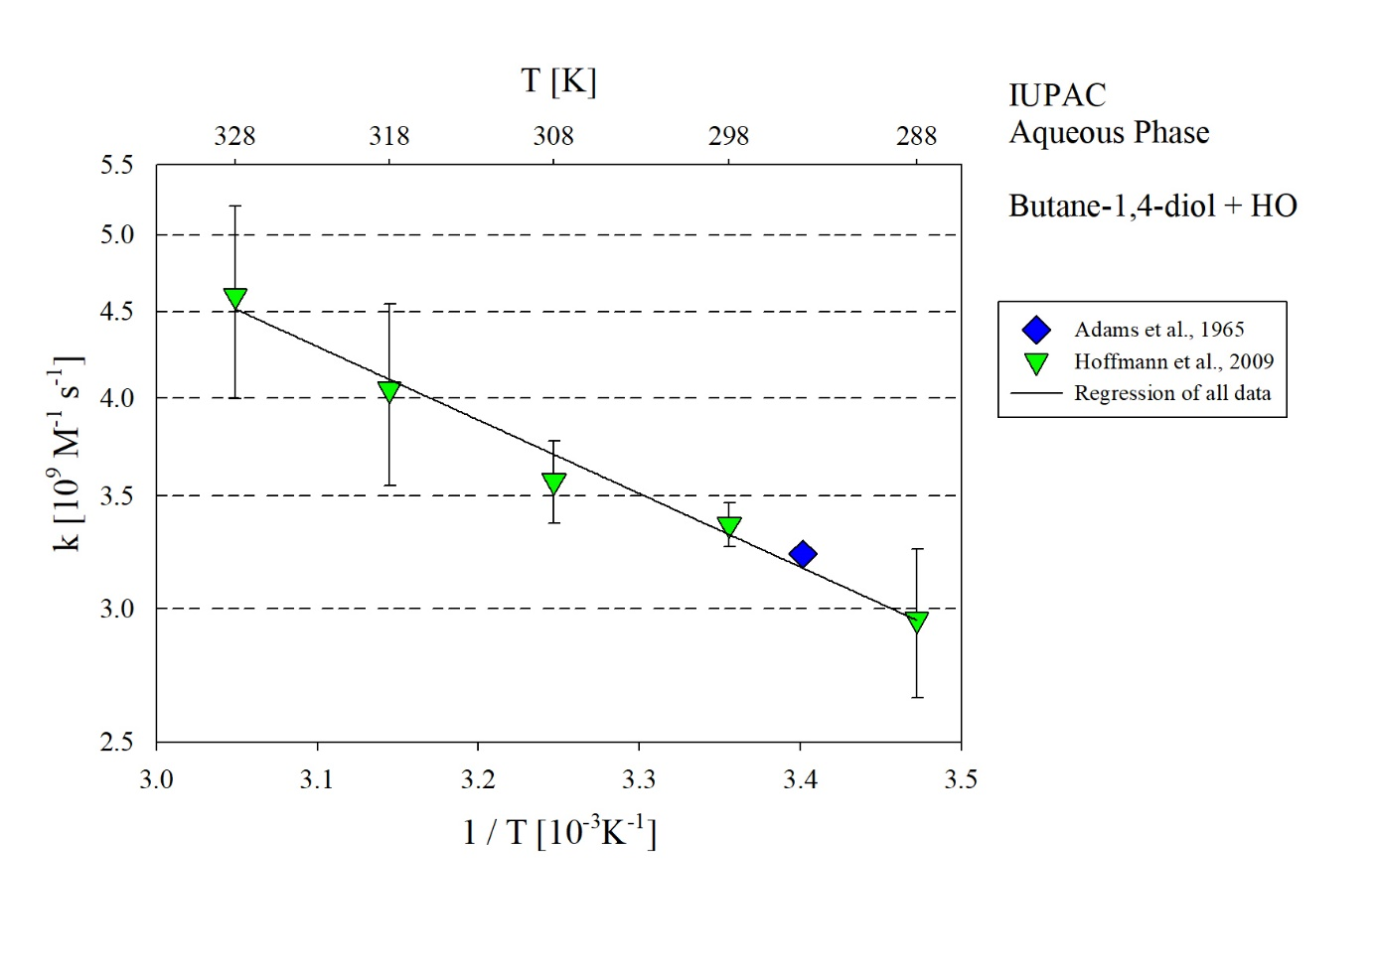
T-dependent rate constants for the reaction of butane-1,4-diol with HO in aqueous solution. All data shown in the figure has been used for regression.

