IUPAC Task Group on Atmospheric Chemical Kinetic Data Evaluation
– Data Sheet AQ_OH_41
Datasheets can be downloaded for personal use only and must not be retransmitted or disseminated either electronically or in hardcopy without explicit written permission.
The citation for this datasheet is: IUPAC Task Group on Atmospheric Chemical Kinetic Data Evaluation, http://iupac.pole-ether.fr.
This datasheet last evaluated: November 2019; last change in preferred values: June 2019

HO (aq) + HO(CH₂)₃OH(aq) → products

Rate coefficient data

k/ L mol⁻¹ s⁻¹ | T/K | pH | I/ mol L⁻¹ | Reference | Technique/ Comments
Relative Rate Coefficients
2.4 × 10⁹ | 294 | 9 | - | Anbar et al., 1966 | PR / UV-Vis (a)
(2.6 ±02) × 10⁹ | 298 | 7 | - | Hoffmann et al., 2009 | LFP-LPA (b)
1.31 × 10¹¹ exp[-(1200 ±250)/T] | 288 - 328 | 7 | - |  | LFP-LPA (b1)

ΔG_{R}° (aq): Aqueous phase thermochemical data not available. As well, gas phase thermochemical data Η_{R}° (g) are not available.

Comments

(a) Reference reaction: HO + PNDA (p-nitrosodimethylaniline); the reference rate constant was determined versus ethanol with k(HO + ethanol) = 1.10 × 10⁹ M⁻¹s⁻¹; recalculation was performed using the selected value for the reference rate coefficient (1.88 × 10⁹ M⁻¹s⁻¹); no values given for initial concentrations; air saturated solutions; all experiments were repeated at least four times and the coefficient of variation was less than ±10%; as no exact temperature is given, T = 294 K is assumed for room temperature.

(b) Radicals generated by laser flash photolysis of H₂O₂ (c(H₂O₂) = 1 × 10⁻⁴ M) at 248 nm (LP-LPA); Reference reaction: HO + SCN⁻ with k(HO + SCN⁻) = 1.24 × 10¹⁰ M⁻¹ s⁻¹ as reported by Chin and Wine (1992); rate constants have been recalculated using the selected values for temperature dependent reference reaction by Zhu et al., 2003; c(KSCN) = 1.59 × 10⁻⁵ M. Arrhenius expression (b1) was calculated using the recalculated experimental data from Hoffmann et al. (2009).

Preferred Values

Parameter | Value | T/K
k / L mol⁻¹ s⁻¹ | 2.50 × 10⁹ | 298
k / L mol⁻¹ s⁻¹ | 1.26 × 10¹¹ exp[-(1200)/T] | 288 - 328

Reliability
Δ log k | ±0.15 | 298
Δ E_{A}/R | ±200 | 288 - 328

Comments on Preferred Values

For the evaluation, the recalculated temperature-dependent data by Hoffmann et al. (2009) and the room temperature rate coefficient by Anbar et al. (1966) have been used for regression. As these data are in general agreement, the result is the mean of them, with an estimated uncertainty of Δ log k = ±0.15 or ±33%.

References

Anbar, M., Meyerstein, D. and Neta, P.: J. Chem. Soc. B, 742-747, 1966.

Hoffmann, D., Weigert, B., Barzaghi, P. and Herrmann, H.: Phys. Chem. Chem. Phys., 11, 9351-9363, 2009

Kraljić, I. and Trumbore, C. N.: J. Am. Chem. Soc. 87(12), 2547-2550, 1965.

Zhu, L., Nicovich, J. M. and Wine, P. H.: Aquat. Sci., 65(4), 425-435, 2003.

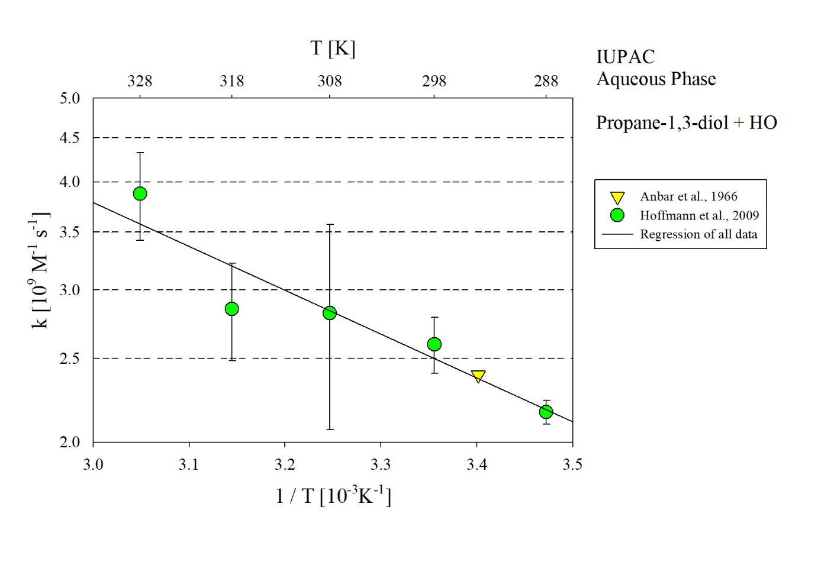
T-dependent rate constants for the reaction of propane-1,3-diol with HO in aqueous solution. Data from Anbar et al. (1966) and Hoffmann et al. (2009).

