IUPAC Task Group on Atmospheric Chemical Kinetic Data Evaluation
– Data Sheet AQ_OH_40
Datasheets can be downloaded for personal use only and must not be retransmitted or disseminated either electronically or in hardcopy without explicit written permission.
The citation for this datasheet is: IUPAC Task Group on Atmospheric Chemical Kinetic Data Evaluation, http://iupac.pole-ether.fr.
This datasheet last evaluated: June 2019; last change in preferred values: June 2019

HO(aq) + HO(CH₂)₂OH(aq) → HOCHCH₂OH + H₂O

(product distribution suggested by Buxton et al., 1988)

Rate coefficient data

k/ L mol⁻¹ s⁻¹ | T/K | pH | I/ mol L⁻¹ | Reference | Technique/ Comments
Relative Rate Coefficients
1.6 × 10⁹ | 294 | ~7 | - | Adams et al., 1965 | PR / UV-Vis (a1)
1.4 × 10⁹ | 294 | ~7 | - |  | (a2)
1.5 × 10⁹ | 294 | 9 | - | Anbar et al., 1966 | PR / UV-Vis (b)
1.8 × 10⁹ | 294 | 2.0-2.2 | - | Scholes and Willson, 1967 | PR / UV-Vis (c)
1.62 × 10⁹ | 294 | - | - | Willson et al., 1971 | PR / UV-Vis (d)
2.30 × 10⁹  2.61 × 10⁹  2.84 × 10⁹  2.72 × 10⁹ | 298 ±2 | - | - | Matheson et al., 1973 | PR / UV-Vis (e)
(1.6 ±0.03) × 10⁹ | 298 | 7 | - | Hoffmann et al., 2009 | LFP-LPA (f)
3.53 × 10¹⁰ exp[-(900 ±110)/T] | 288 – 328 | 7 | - |  | (f1)

ΔG_{R}° (aq): Aqueous phase thermochemical data not available. As well, gas phase thermochemical data Η_{R}° (g) are not available.

Comments

(a) Reference reactions: HO + CO₃²⁻ with k(HO + CO₃²⁻) = 2.0 × 10⁸ M⁻¹s⁻¹ [3.77 × 10⁸ M⁻¹s⁻¹] (a1); HO + SCN⁻ with k(HO + SCN⁻) = 6.6 × 10⁹ M⁻¹s⁻¹ [1.10 × 10¹⁰ M⁻¹s⁻¹, Zhu et al., 2003] (a2); no values given for the initial concentrations of the reactants; pH is given as natural; as no exact temperature is given, a room temperature of 294 K is assumed.

(b) Reference reaction: HO + PNDA (p-nitrosodimethylaniline); reference rate constant was determined versus ethanol with k(HO + ethanol) = 1.10 × 10⁹ M⁻¹s⁻¹; rate coefficients have been recalculated using the selected value for the reference reaction 1.88 × 10⁹ M⁻¹s⁻¹; no values given for initial concentrations; air saturated solutions; all experiments were repeated at least four times and the coefficient of variation was less than ±10%; as no exact temperature is given, a room temperature of 294 K is assumed.

(c) Aerated solutions of thymine (c(thymine) = 8 × 10⁻⁵ M) were irradiated (pH range: 1.5 – 9); rate constant was determined relative to thymine reference with k(HO + thymine) = 4.3 × 10⁹ M⁻¹ s⁻¹; rate constants have been recalculated using the selected value for the reference reaction (5.38 × 10⁹ M⁻¹s⁻¹); as no exact temperature is given, a room temperature of 294 K is assumed.

(d) Reference reaction: HO + [Fe(CN)₆]⁴⁻; k(HO + [Fe(CN)₆]⁴⁻) = (9.3 ±0.05) × 10⁹ M⁻¹ s⁻¹; rate constants have been recalculated using the selected values for the reference reactions (1.03 × 10¹⁰ M⁻¹s⁻¹); c([Fe(CN)₆]⁴⁻) = 2 × 10⁻³ mol/L (no information on counterions); reference values were normalized to k(HO + ethanol) = 1.85 × 10⁹ M⁻¹s⁻¹; as no exact temperature is given, a room temperature of 294 K is assumed.

(e) Rate constants were determined relative to the reference reaction with k(HO + [Fe(CN)₆]⁴⁻) = 0.93 × 10⁻¹⁰ M⁻¹ s⁻¹; rate constants have been recalculated using the selected value for the reference reaction (1.10 × 10¹⁰ M⁻¹s⁻¹); Depending on four different concentrations of ethylene glycol (2 × 10⁻³ M, 4 × 10⁻³ M, 8 × 10⁻³ M and 1 × 10⁻² M), rate constants were measured as listed.

(f) Radicals generated by laser flash photolysis of H₂O₂ (c(H₂O₂) = 1 × 10⁻⁴ M) at 248 nm (LP-LPA); Reference reaction: HO + SCN⁻ with k(HO + SCN⁻) = 1.24 × 10¹⁰ M⁻¹ s⁻¹ as reported by Chin and Wine (1992); rate constants have been recalculated using the selected values for reference reactions (Zhu et al., 2003); c(KSCN) = 1.59 × 10⁻⁵ M. Arrhenius expression (f1) was calculated using the recalculated experimental data from Hoffmann et al. (2009).

Preferred Values

Parameter | Value | T/K
k / L mol⁻¹ s⁻¹ | 1.65 × 10⁹ | 298
k / L mol⁻¹ s⁻¹ | 2.82 × 10¹⁰ exp[-(850)/T] | 288 - 328

Reliability
Δ log k | ±0.09 | 298
Δ E_{A}/R | ±150 | 288 – 328

Comments on Preferred Values

For the Arrhenius equation regression, the temperature dependent data by Hoffmann et al. (2009), as well as the recalculated rate coefficients by Adams et al. (1965), Anbar et al. (1966), Scholes and Willson (1967) and Willson et al. (1971) have been considered. Due to the hugely different determinations by Matheson et al. (1973) to, their data is not included in the regression. The recommended rate constant is in good agreement with the temperature dependent data of Hoffmann et al. (2009). The estimated uncertainty is given as Δ log k = 0.09 or ±20%.

References

Adams, G. E., Boag, J. W. and Michael, B. D.: Trans. Faraday Soc., 61, 1417-1424, 1965.

Adams, G.E., Boag, J.W., Currant, J. and Michael, B.D., Pulse Radiolysis, Ebert, M., Keene, J.P., Swallow, A.J. and Baxendale, J.H. (eds.): Academic Press, New York, 131-143, 1965.

Anbar, M., Meyerstein, D. and Neta, P.: J. Chem. Soc. B, 742-747, 1966.

Buxton, G. V., Greenstock, C. L., Helman, W. P. and Ross, A. B.: J. Phys. Chem. Ref. Data, 12(2), 513 – 886, 1988.

Chin, M., and Wine, P. H: J. Photochem. Photobiol., A, 69(1), 17-25, 1992.

Hoffmann, D., Weigert, B., Barzaghi, P. and Herrmann, H.: Phys. Chem. Chem. Phys., 11, 9351-9363, 2009

Kraljić, I. and Trumbore, C. N.: J. Am. Chem. Soc. 87(12), 2547-2550, 1965.

Matheson, M. S., Mamou, A., Silverman, J. and Rabani, J.: J. Phys. Chem., 77(20), 2420-2424, 1973.

Monod, A. and Doussin, J. F.: Atmos. Environ., 42, 7611- 7622, 2008.

Scholes, G. and Willson, R.L.: Trans. Faraday Soc., 63, 2983-2993, 1967.

Willson, R. L., Greenstock, C. L., Adams, G. E., Wageman, R. and Dorfman, L. M.: Int. J. Radiat. Phys. Chem., 3(3), 211-220, 1971.

Zhu, L., Nicovich, J. M. and Wine, P. H.: Aquat. Sci., 65(4), 425-435, 2003.

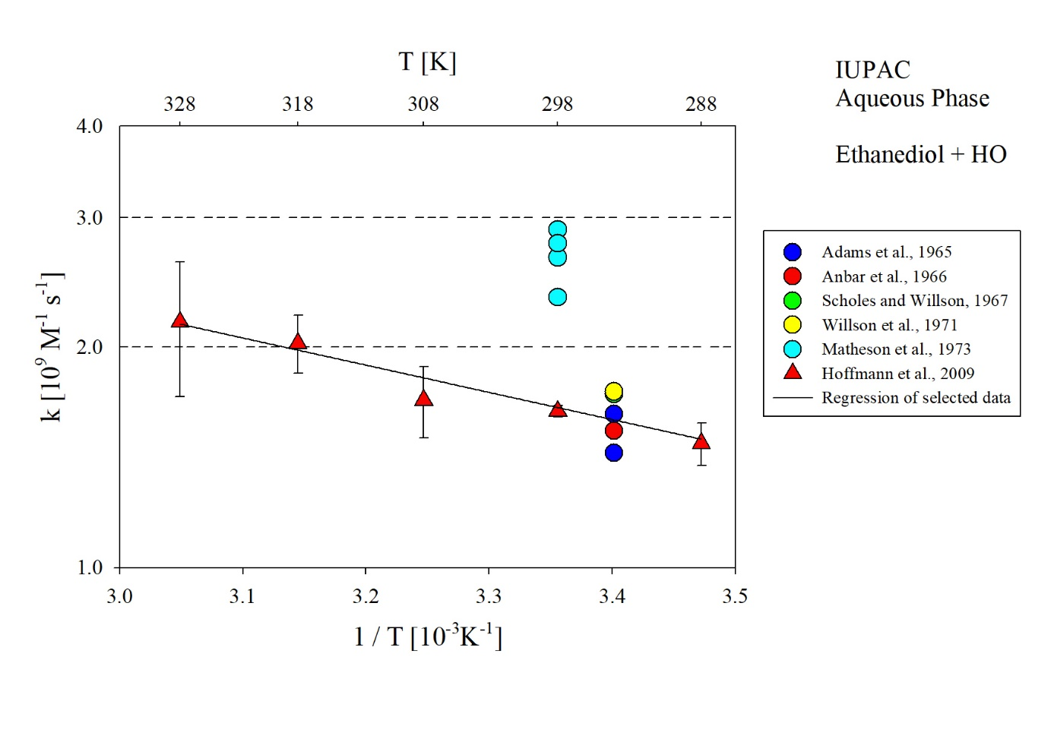
T-dependent rate coefficients for the reaction of ethanediol with HO radical in aqueous solution. The data of Matheson et al. (1973) is excluded from the evaluation.

