IUPAC Task Group on Atmospheric Chemical Kinetic Data Evaluation – Data Sheet CGI_14
Datasheets can be downloaded for personal use only and must not be retransmitted or disseminated either electronically or in hardcopy without explicit written permission. The citation for this data sheet is: IUPAC Task Group on Atmospheric Chemical Kinetic Data Evaluation, (http://iupac.pole-ether.fr).
This datasheet last evaluated: February 2020; last change in preferred values: February 2020

(CH₃)₂COO + M → products

Rate coefficient data

k/ s⁻¹ | Temp./K | Reference |  | Technique/Comments
Absolute Rate Coefficients
370 ± 34 | 298 | Huang et al., 2015 |  | PLP-LPUVA (a)
269 ± 82 | 283 | Smith et al., 2016 |  | PLP-Slow Flow-LPUVA (b)
361 ± 49 | 298
628 ± 60 | 310
916 ± 56 | 323
305 ± 70 | 293 | Chhantyal-Pun et al., 2017 |  | PLP- PIMS/CRDS (c)
Relative Rate Coefficients
605 ± 109 | 293 | Berndt et al., 2012 |  | RR-FTIR/ TDLS (d)
416 ± 121 | 278 | Berndt et al., 2014 |  | FT/CI-APi-TOF MS (e)
722 ± 52 | 293
2449 ± 865 | 323
4280 ± 544 | 343
929 ± 220 | 298-299 | Newland et al., 2015 |  | RR-FTIR/UVA/UVF (f)

Comments

- (CH₃)₂COO was generated from 248 nm pulsed photolysis of a gaseous mixture consisting of 2,2-diiodopropane ((CH₃)₂CI₂), O₂ and buffer gas (N₂), (CH₃)₂CI₂ + hν → (CH₃)₂CI + I, at about 13 – 1030 mbar (10 - 770 Torr) total pressure and 298 K. (CH₃)₂COO was monitored by UV absorption in the region 300 – 450 nm. IO was also detected, which is formed from the second channel, (CH₃)₂CI + O₂ → (CH₃)₂COO + IO. First order decay rate constants decreased with total [(CH₃)₂COO] to a limiting value at low initial radical concentration, when influence of radical-CI reactions is minimal. We infer this limiting value to be due to thermal decomposition. The cited value of k was obtained by linear extrapolation of a plot of the pseudo-first order rate constants at 267 mbar (200 Torr) to the limit at zero absorption from (CH₃)₂COO.
- (CH₃)₂COO was generated from pulsed photolysis of a gaseous mixture consisting of 2,2-diiodopropane, (CH₃)₂CI₂, O₂, and buffer gas (N₂) at 248 nm, (CH₃)₂CI₂ + hν → (CH₃)₂CI + I, at a total pressure of 200 Torr. (CH₃)₂COO was monitored by time-resolved UV absorption due to the B̃ (1A′) ← X̃(1A′) electronic transition. The amount of (CH₃)₂COO formed was estimated using a cross-section σ = 1.6 × 10⁻¹⁷ cm² at 340 nm. Kinetic decays were recorded in the temperature range 283-323 K. The decay kinetics exhibited a complex mixed first and second order form, due to thermal decomposition, self-reaction and reaction of (CH₃)₂COO with other radical species produced following photolysis. k was determined by numerical simulation, making use of an optimized value of the second order component (mainly due to self-reaction), which was well defined in experiments at the highest initial concentrations. The values of k increased significantly with temperature. The results are consistent with k = 7.25 × 10⁶ exp[-(2919 ± 604)/T)]. (CD₃)₂COO kinetics were also investigated using the precursor (CD₃)₂CI₂. k for (CD₃)₂COO at 298 K was estimated to be <100 s⁻¹, with no significant T dependence.
- (CH₃)₂COO was formed by laser photolysis of (CH₃)₂CI₂ in the presence of O₂ and characterized by synchrotron photoionization mass spectrometry; and also by cavity ringdown ultraviolet absorption spectroscopy. Cavity ringdown measurements of (CH₃)₂COO loss without added reagents display a combination of first- and second-order decay kinetics, which were deconvolved to derive values for both the (CH₃)₂COO self-reaction rate constant, and the unimolecular thermal decay constant, k. The cited value is a mean of four determinations of k over the pressure range 13 - 131 mbar. Both k and the self-reaction rate constant were independent of pressure in this range.
- Study of the 2,3-dimethyl-but-2-ene + O₃ reaction in the presence of 1 bar of synthetic air with and without added SO₂, in a flow system, at 1 bar pressure and 50 % RH. Either propane or butane were also present to scavenge HO radicals. Formation of H₂SO₄ from the reaction of (CH₃)₂COO with SO₂ was monitored with CIMS, using NO₃⁻ as reagent ion. The time dependence of H₂SO₄ production after addition of different [SO₂] allowed estimation of k_{loss} = (3.0 ± 0.4) s⁻¹ for (CH₃)₂COO, and a rate constant ratio k_{loss}/k((CH₃)₂COO + SO₂) = (3.9 ± 0.7) × 10¹² molecule cm⁻³; where k_{loss} is the total first-order loss rate due to decomposition and reaction with H₂O. Because the (slow) reaction of (CH₃)₂COO with H₂O can be neglected as a significant removal process for (CH₃)₂COO under the experimental conditions, we infer that of k_{loss} = k. The tabulated value of k is based on the rate constant ratio, which agrees well with that reported in a subsequent study (Berndt et al., 2014). k is placed on an absolute basis using k((CH₃)₂COO + SO₂) = 4.23 × 10⁻¹³ exp(1760/T) cm³ molecule⁻¹ s⁻¹ (IUPAC, current recommendation); although it is noted that the resultant value is not in good agreement with their reported absolute estimate.
- (CH₃)₂COO prepared by O₃ + 2,3-dimethyl-but-2-ene reaction in the presence of SO₂ and propane (HO radical scavenger) in a flow system, equipped with CIMS for detection of H₂SO₄ using NO₃⁻ as reagent ion. Total pressure = 1 bar. The effect of [H₂O] (RH = 2 – 50%) on yield of H₂SO₄ was negligible, and it was deduced that thermal decomposition was the dominant reaction competing with (CH₃)₂COO + SO₂ reaction. A distinct temperature dependence of H₂SO₄ formation was observed over the studied range (278−343 K), attributed mainly to the thermal decomposition of (CH₃)₂COO. The reported values of k/k((CH₃)₂COO + SO₂) were placed on an absolute basis using k((CH₃)₂COO + SO₂) = 4.23 × 10⁻¹³ exp(1760/T) cm³ molecule⁻¹ s⁻¹ (IUPAC, current recommendation). An Arrhenius plot of the resultant values of k vs. 1/T, is linear, yielding a value of E_{a} ≈ 29 kJ mol⁻¹.
- The removal of SO₂ in the presence of 2,3-dimethyl-but-2-ene/ozone systems was measured as a function of humidity in the EUPHORE simulation chamber, under atmospheric boundary layer conditions. Cyclohexane was also present to scavenge HO radicals. SO₂ and O₃ concentrations were measured using conventional fluorescence and UV absorption monitors, respectively; the alkene concentration was determined via FTIR spectroscopy. The yield of (CH₃)₂COO from the 2,3-dimethyl-but-2-ene + O₃ reaction was reported to be (0.32 ± 0.20). The observed SO₂ removal kinetics are consistent with the rate constant ratio: k/k((CH₃)₂COO + SO₂) = (6.3 ± 1.4) × 10¹² molecule cm⁻³. The tabulated value of k was placed on an absolute basis using k((CH₃)₂COO + SO₂) = 4.23 × 10⁻¹³ exp(1760/T) cm³ molecule⁻¹ s⁻¹ (IUPAC, current recommendation).

Preferred Values

Parameter | Value | T/K
k/ s⁻¹ | 400 | 298
k/ s⁻¹ | 7.2 × 10⁶ exp(-2920/T) | 280-330

Reliability
Δ log k | ± 0.2 | 298
Δ (E/R) | ± 700 | 280-330

Comments on Preferred Values
k has been determined in three direct studies; by Huang et al. (2015) at 298 K, by Smith et al. (2016), who also reported a temperature dependence study over the range 283–323 K, and by Chhantyal-Pun et al. (2017) at 293 K. The results at near ambient temperatures from these studies are all consistent, and the absence of pressure dependence over the range 13-130 mbar (Chhantyal-Pun et al., 2017) indicates the measurements were made at the high-pressure limit. The decomposition rate constant shows a substantial increase with temperature. The preferred values of k are based on a fit to all the direct data, with E/R constrained to a value of 2920 K, based on the activation energy reported by Smith et al. (2016).
The relative rate determinations from ozonolysis of 2,3-dimethyl-but-2-ene, using reaction of (CH₃)₂COO with SO₂ as a reference, are also in good agreement; but consistently give values of k over a factor of 2 higher than the direct measurements at room temperature. The temperature dependence of k inferred from the data of Berndt et al. (2014) (see comment (e)) supports the direct measurements of Smith et al. (2016), and gives a comparable, but slightly higher, activation energy. An analysis of the indirect data alone provides a value k = 1.11 × 10⁸ exp(-3500/T) s⁻¹, with a value 880 s⁻¹ at 298 K. The origins of this consistent discrepancy between the direct and relative rate determinations are currently unclear, although it is noted that the mechanism and products of the reference (CH₃)₂COO + SO₂ reaction are not fully characterized at atmospheric pressure (see data sheet CGI_18).
The preferred value of k at 298 K is in good agreement with the value of 369 s⁻¹ calculated by Liu et al. (2014), using master-equation calculations and RRKM theory. Smith et al. (2016) reported theoretical calculations for (CH₃)₂COO and (CD₃)₂COO which show a strong temperature dependence in k, with Arrhenius activation energies of 35.5 and 56.4 kJ mol⁻¹ respectively. The theoretical and experimental temperature dependences are consistent for (CH₃)₂COO, and the experimentally observed slower decomposition of (CD₃)₂COO is predicted.
The quantum chemical studies predict that decomposition of (CH₃)₂COO occurs via a 1,4 H-atom transfer to form the vinyl hydroperoxide intermediate, 2-hydroperoxypropene. This process is exothermic, and HO is produced from its subsequent decomposition. UV depletion studies coupled with photoionization mass spectrometry have shown relative yields of the HO radical to be greater from (CH₃)₂COO than from CH₂OO (Fang et al. 2016). These observations confirm that the facile 1,4 intramolecular hydrogen transfer leads to much faster unimolecular decomposition rate for (CH₃)₂COO compared with CH₂OO, for which the mechanism is unavailable.

References

Berndt, T., Jokinen, T., Mauldin, R. L., Petäjä, T.: Herrmann, H., Junninen, H., Paasonen, P., Worsnop, D. R. and Sipilä, M.: J. Phys. Chem. Lett., 3, 2892, dx.doi.org/10.1021/jz301158u, 2012.
Berndt, T., Jokinen, T., Sipilä, M., Mauldin, R. L., Herrmann, H., Stratmann, F., Junninen, H. and Kulmala, M.: Atmos. Environ., 89, 603, 2014.
Chhantyal-Pun, R., Welz, O., Savee J. D., Eskola, A. J., Lee, E. P. F., Blacker, L., Hill, H. R., Ashcroft, M., Khan, M. A. H., Lloyd-Jones, G. C., Evans, L., Rotavera, B., Rotavera H., Osborn, D. L., Mok, D. K. W., Dyke, J. M., Shallcross, D. E., Percival, C. J., Orr-Ewing, A. J. and Taatjes, C. A.: J. Phys. Chem. A, 121, 4, https://doi.org/10.1021/acs.jpca.6b07810, 2017.
Fang, Y., Liu, F., Barber, V. P., Klippenstein, S. J., McCoy, A. B. and Lester, M. I.: J. Chem. Phys., 144(6), 061102, doi: 10.1063/1.4941768, 2016.
Liu, F., Beames, J. M., Green, A. M., Lester, M. I.: J. Phys. Chem. A, 118(12), 2298, (2014).
Huang, H.-L., Chao, W. and Lin, J. J.-M.: Proc. Natl. Acad. Sci., 112(35), 10857, doi: 10.1073/pnas.1513149112, 2015.
Smith, M. C., Chao, W., Takahashi, K., Boering, K. A. and J. J.-M.: J. Phys. Chem. A, 120(27), 4789, 2016.
Newland, M. J., Rickard, A. R., Alam, M. S., Vereecken, L., Muñoz, A., Rod́enas, M. and Bloss, W. J.: Phys. Chem. Chem. Phys., 17, 4076, 2015.

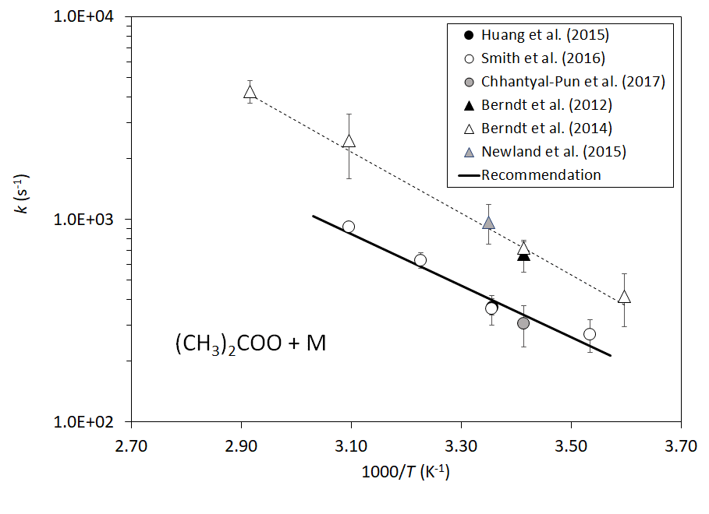

Arrhenius plot of k((CH₃)₂COO + M). Direct determinations are shown as circlular points; relative rate determinations are shown as triangular points. The displayed errors are the experimental limits cited by the authors (but do not include uncertainty in the reference reaction for the relative rate studies). The full line is the IUPAC recommendation, k = 7.2 ×10⁶ exp(-2920/T) s⁻¹. The broken line is a fit to the relative rate data, k = 1.11 × 10⁸ exp(-3500/T) s⁻¹.

